PROPOSED GENERAL PLAN LAND USE AND ZONING CODE DESIGNATIONS

ALISAL MARKETPLACE
PROPOSED GENERAL PLAN LAND USE DESIGNATION
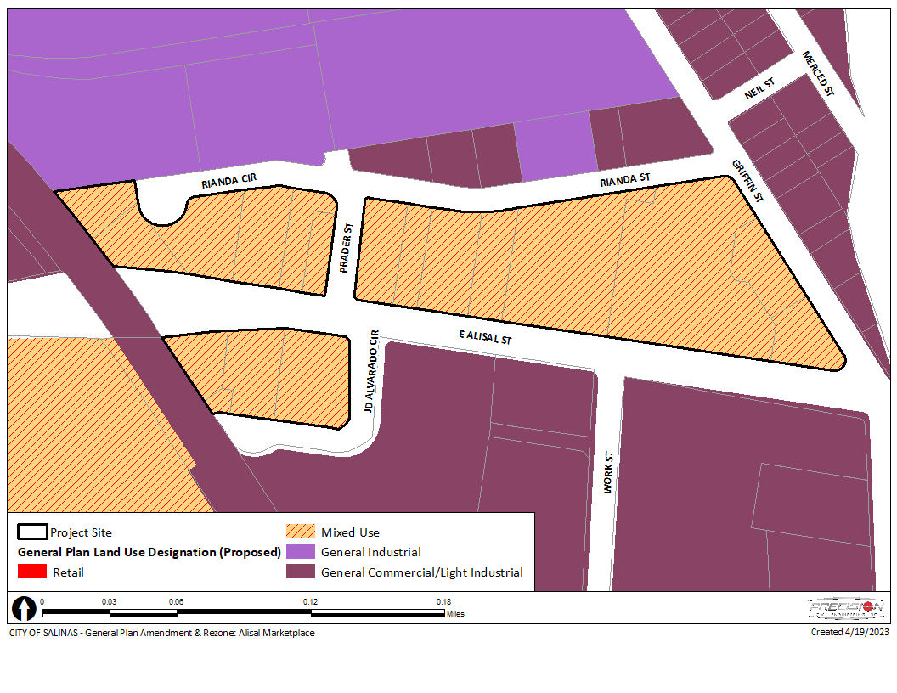
ALISAL MARKETPLACE
PROPOSED ZONING DESIGNATION
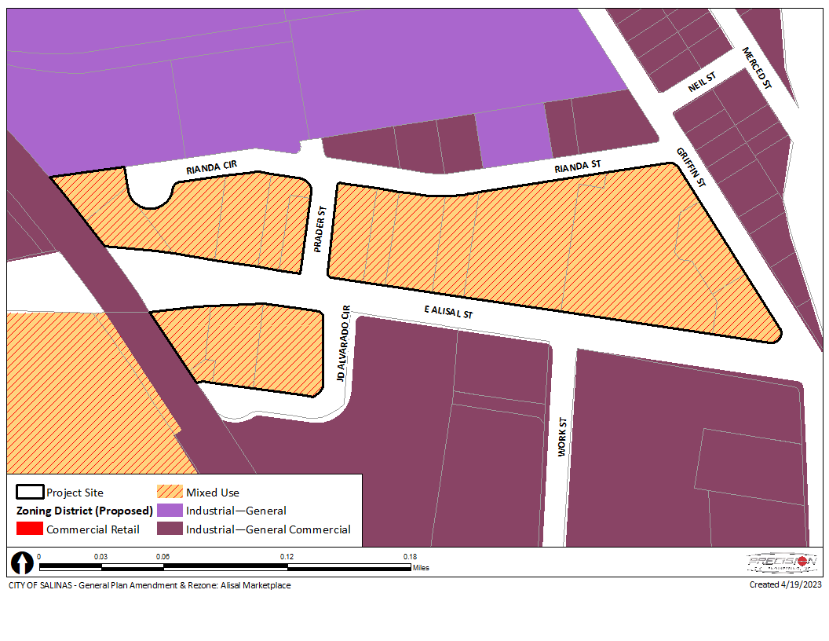

EDGE OF DOWNTOWN/FRONT AND JOHN STREETS
PROPOSED GENERAL PLAN LAND USE DESIGNATION
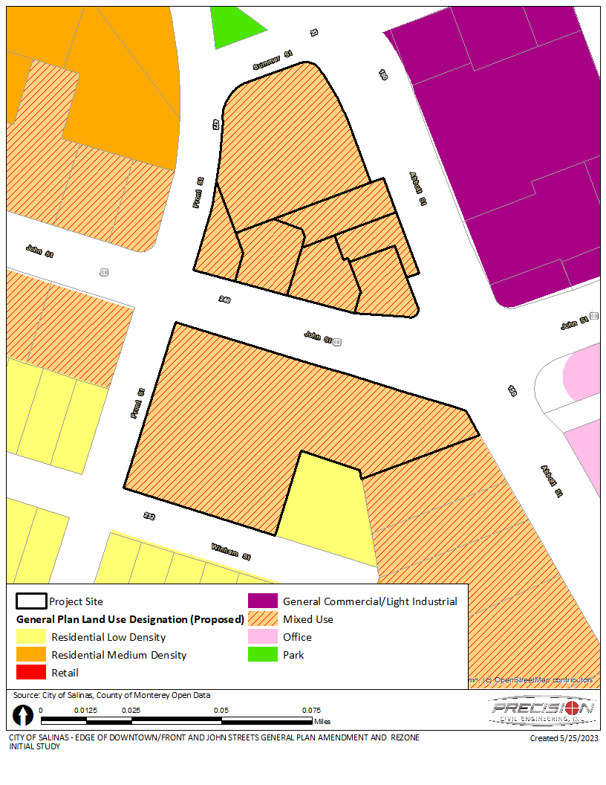

EDGE OF DOWNTOWN/FRONT AND JOHN STREETS
PROPOSED ZONING DESIGNATION
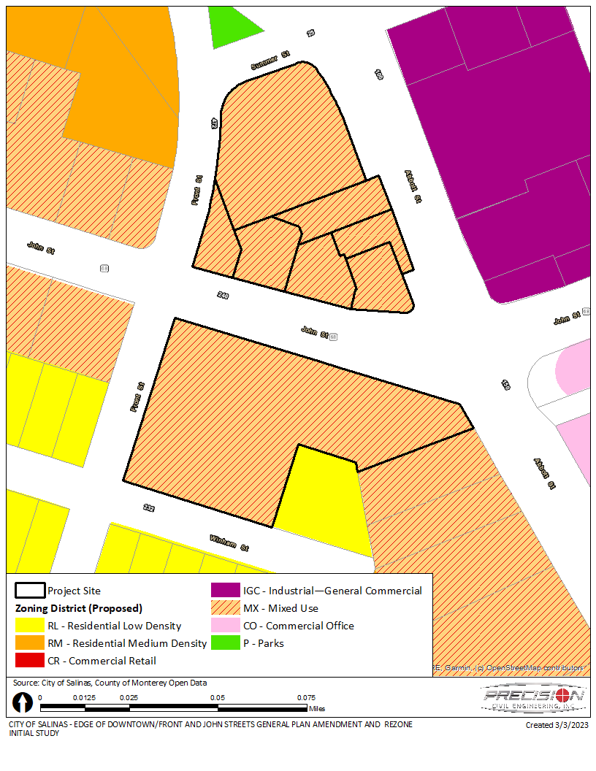

FOODS CO SHOPPING CENTER
PROPOSED GENERAL PLAN LAND USE DESIGNATION
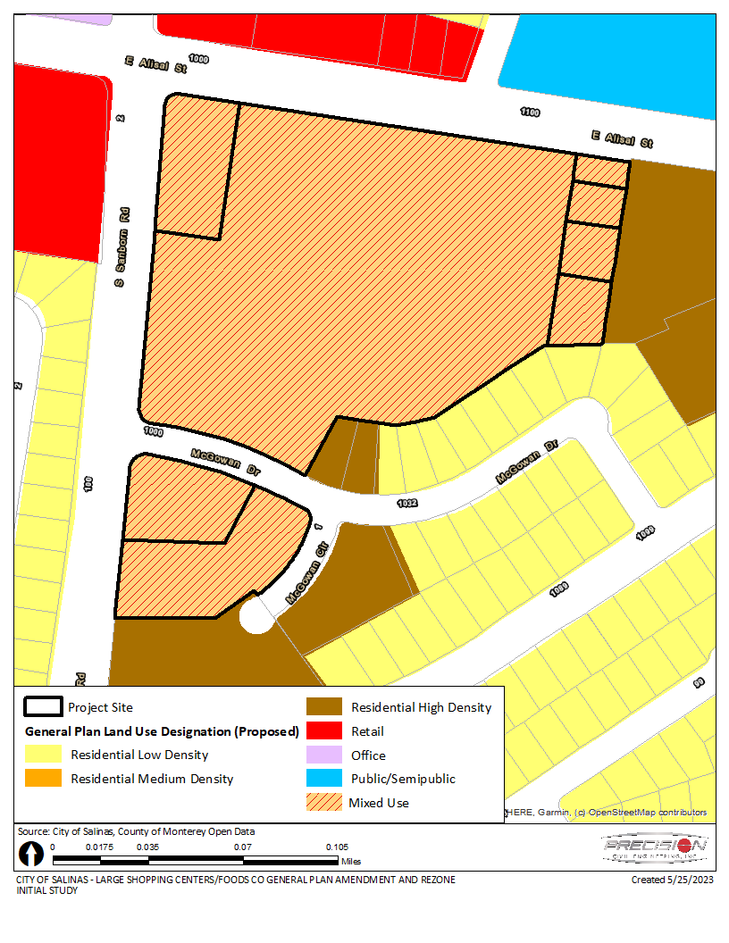

FOODS CO SHOPPING CENTER
PROPOSED ZONING DESIGNATION
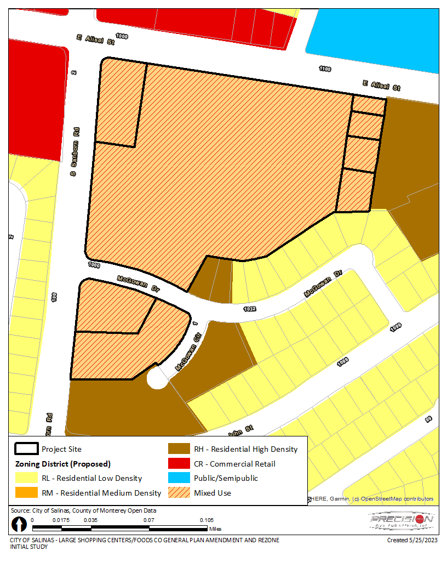

LAUREL WEST SHOPPING CENTER
PROPOSED GENERAL PLAN LAND USE DESIGNATION
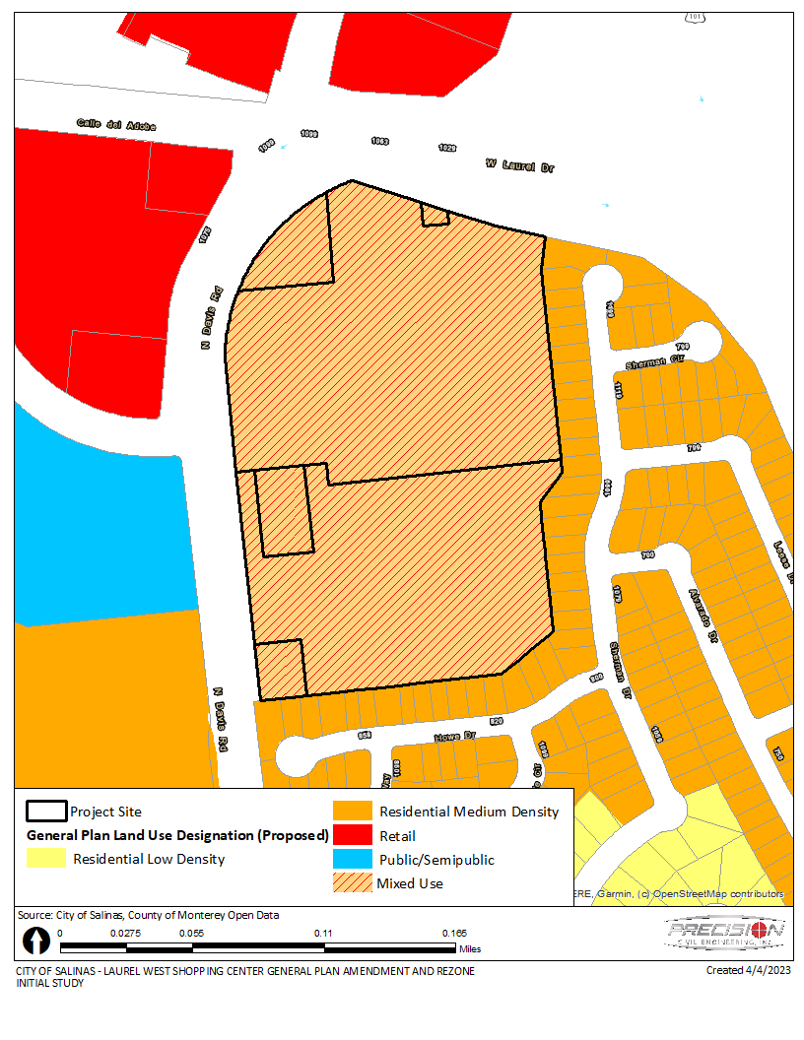

LAUREL WEST SHOPPING CENTER
PROPOSED ZONING DESIGNATION
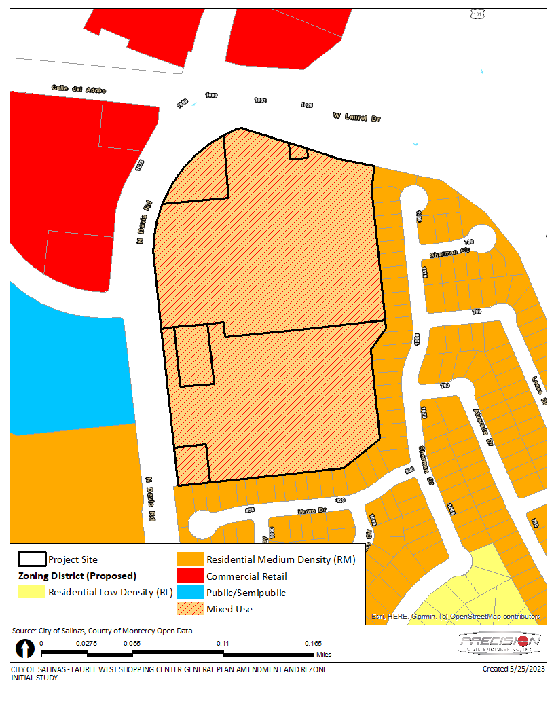

SEARS (NORTHRIDGE MALL)
PROPOSED GENERAL PLAN LAND USE DESIGNATION
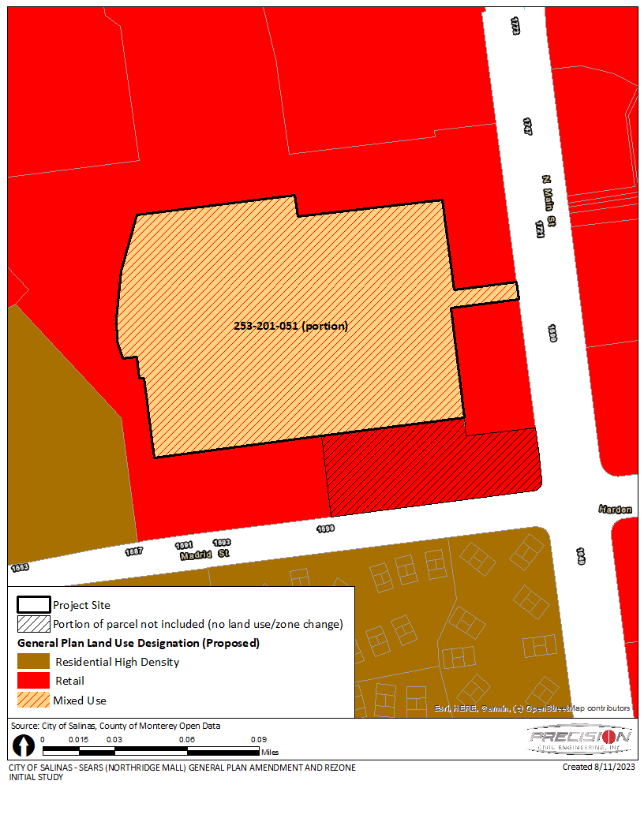

SEARS (NORTHRIDGE MALL)
PROPOSED ZONING DESIGNATION
