DATE: OCTOBER 18, 2022
DEPARTMENT: ADMINISTRATION
OFFICE OF THE CITY ATTORNEY
COMMUNITY DEVELOPMENT DEPARTMENT

FROM: STEVEN S. CARRIGAN, CITY MANAGER
CHRISTOPHER A. CALLIHAN, CITY ATTORNEY
MEGAN HUNTER, COMMUNITY DEVELOPMENT DIRECTOR
LISA BRINTON, ASSISTANT COMMUNITY DEVELOPMENT DIRECTOR

TITLE: INCLUSIONARY HOUSING ORDINANCE—DOWNTOWN EXEMPTION [SALINAS MUNICIPAL CODE SECTION 17-8(d)]

RECOMMENDED MOTION:

No specific action is recommended.

The City Council is asked to consider whether the exemption provided to residential developments in the downtown area [Salinas Municipal Code section 17-8(d)] should be repealed.

EXECUTIVE SUMMARY:

On September 13, 2022, Community Development Department staff presented an Administrative Report to the City Council on the Inclusionary Housing Ordinance and the Downtown Area Exemption. During the September 13, 2022, City Council meeting, Council members Barrera and Rocha requested that that exemption provided to residential developments in the downtown area (“downtown exemption”) be brought back to the City Council for further discussion and consideration.

BACKGROUND:

The downtown exemption is set out in Section 17-8(d) of the Salinas Municipal Code, as follows:

“This article shall not apply to any of the following:
…

(d) Residential developments located within the downtown area, unless the City Council by resolution determines that based on market conditions, the provisions of this article will be applied in the downtown area.”

The “downtown area” is defined at Section 17-7(l) of the Salinas Municipal Code, as follows:

“(l) ‘Downtown Area’ means the are within the boundaries of the Central City Overlay District as defined per Zoning Code [section] 37-40.300.” For reference, the map provided in Zoning Code Section 37-40.300 is provided below. To be clear, the downtown exemption applies to all areas within the area outlined in the bolded black line. The Downtown Core Area (shaded in grey) is within the boundaries of the downtown exemption.

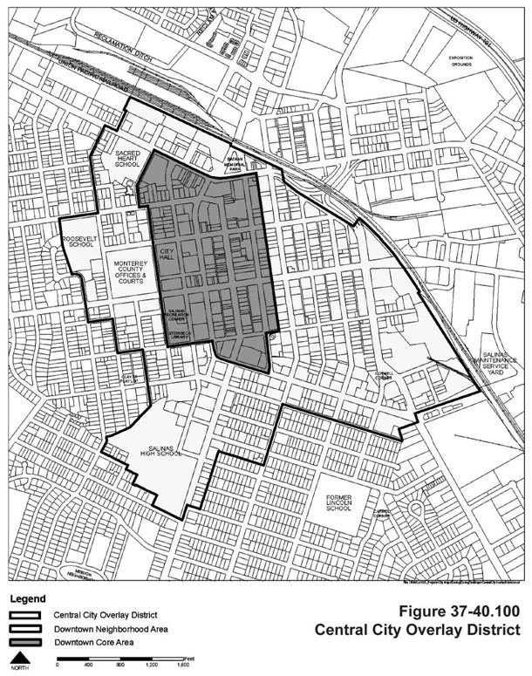

As referenced in the September 13, 2022, Staff Report, the downtown exemption that encompasses the Central City Overlay District was incorporated into the Inclusionary Housing Ordinance based on the findings of a 2017 Housing Target Market Analysis which acknowledged the untested residential development potential within the Downtown Area. Based on that analysis, the Downtown Area was exempted from the inclusionary requirements applicable elsewhere in the city.

In preparation for the City Council’s discussion of the Inclusionary Housing Ordinance, generally, the Community Development Department commissioned an update to the 2017 Housing Target Market Analysis to reflect current market conditions. While the 2022 update provided only initial findings in advance of a more comprehensive update of the analysis, the update supports the 2017 fundings and preliminary concludes “that the inclusionary housing exemption should be extended and reconsidered at the time of the Housing Element Update.”

The 2017 analysis found that:

- There is substantial demand for near-term ownership and rental residential projects in Downtown.
- Consumer preference exists for market rate infill housing opportunities.
- There is traction for Downtown adaptive reuse projects.
- There are significant market risks to Downtown housing development including crime/public safety, homelessness, lack of open space, low school performance, traffic, and an untested market.
- The City should incorporate housing incentives that might contribute to development cost reductions to improve the market for downtown development including the exemption to the Inclusionary Housing Ordinance.

2022 HTMA Update found that:

- Implementing inclusionary housing in the Downtown Area would constrain the current momentum of residential development in the Downtown as the early adopters establish proof of market in this nascent environment.
- The housing market in Salinas has become more expensive since the onset of the Covid-19 pandemic.
- Home ownership is becoming less affordable as housing prices continue to increase, rental units generally present a more affordable option for residents.
- Current construction costs are extremely high.
- Market rate rental and ownership RD-60 (density of 60 units per acre) prototypes both have a negative residual value land value (the difference between a project’s high construction costs and its lower market value).
- Micro-rental units show the best project feasibility.

Evidence of HTMA findings is the limited number of residential units that have been developed in the Downtown since 2017 even with the incentives provided under the Adaptive Reuse Ordinance. Recognizing that the conversion of older, in some cases historic, buildings is costly, the City established an Adaptive Reuse Ordinance in 2018 that relaxes or eliminate identified development standards to incentivize the conversion of older, underutilized commercial buildings to residential use in the Central City Overlay District. Even with these incentives only 69 units have been permitted and are currently under construction; 300 Main Street (Bruhn Building) with 19 units and 301 Main (Rabobank Building) with 50 units. A Site Plan for 123 W. Alisal (The Californian Building) with 40 units was approved but expired as the applicants found the proposed project financially infeasible.

During their September 13, 2013, presentation, Community Development staff indicated that given current workload constraints and the City Council’s current direction related to other priority projects they could begin work on a comprehensive update to the Inclusionary Housing Ordinance and Guidelines, including the downtown exemption, in mid-2023. That effort would require robust community engagement including, for example, reinstitution of a Technical Advisory Committee to include community members and housing advocates, among others.

ALTERNATIVES AVAILABLE TO THE CITY COUNCIL

The downtown exemption has been brought back to the City Council for consideration specifically at the request of Council members Barrera and Rocha. With respect to the downtown exemption, the City Council may take the following actions:

- Leave the downtown exemption in place pending a more comprehensive review and update of the Inclusionary Housing Ordinance and Guidelines as a part of the Housing Element Update, scheduled to begin in mid-2023.

- Repeal the downtown exemption. The City Council has two means by which it may repeal the downtown exemption.

  - Repeal the downtown exemption based on findings supported by an analysis that, based on market conditions, the Inclusionary Housing Ordinance and Guidelines should be applied in the downtown area. (Salinas Municipal Code Section 17-8(d).)

Staff does not recommend the City Council choose this option as there is no analysis in the record to support the repeal of the downtown exemption based on market conditions. To the contrary, the 2022 update to the 2017 Housing Target Market Analysis at least preliminarily concludes that based upon current market conditions the downtown exemption should remain in place. Based upon the current record, the City Council could not make sufficient findings to support approval of a Resolution to repeal the downtown exemption based upon Salinas Municipal Code Section 17-8(d).

  - Repeal Section 17-8(d) in its entirety, thereby removing it from the Municipal Code. This action would remove this subsection from the Municipal Code in its entirety thereby eliminating the downtown exemption. This action would also eliminate the City Council’s ability later approve a Resolution that based on then existing market conditions that the exemption should be re-applied to the downtown area. A new ordinance would be required to reinsert the downtown exemption within the Inclusionary Housing Ordinance. The City Council would need to base this action on findings (justification and support for its decision to remove this provision from the Municipal Code and thereby lifting the downtown exemption); however, those findings do not specifically need to be made based on an analysis of market conditions as is required by Municipal Code Section 17-8(d).

- Amend Section 17-8(d) to apply only to adaptive reuse residential developments in the downtown. The downtown exemption would no longer apply to new construction residential development. This amendment would be revisited as part of a more comprehensive review and update of the Inclusionary Housing Ordinance and Guidelines along with the Housing Element update, scheduled to start mid-2023.

- The City Council may otherwise direct staff how to proceed regarding the downtown exemption.

CEQA CONSIDERATION:

The City of Salinas has determined that the proposed action does not have the potential for causing a significant effect on the environment. CEQA Guidelines Section 15061 includes the general rule that CEQA applies only to activities which have the potential for causing a significant effect on the environment. Where it can be seen with certainty that there is no possibility that the activity in question may have a significant effect on the environment, the activity is not subject to CEQA. Because the proposed action and this matter have no potential to cause any effect on the environment, or because it falls within a category of activities excluded as projects pursuant to CEQA Guidelines section 15378, this matter is not a project. Because the matter does not cause a direct or foreseeable indirect physical change on or in the environment, this matter is not a project. Any subsequent discretionary projects resulting from this action will be assessed for CEQA applicability.

STRATEGIC PLAN INITIATIVE:

The Inclusionary Housing Ordinance and Guidelines support the City Council’s Strategic Plan 2022-2025 Goals and Strategies including Economic Development, Housing/Affordable Housing, and Effective and Culturally Responsive Government.

DEPARTMENTAL COORDINATION:

Implementation of the Inclusionary Ordinance is coordinated and supported by multiple Divisions and Departments including, the Housing Division, Current Planning Division, Advanced Planning & Project Implementation Division of the Community Development Department; Permit Services; Economic Development; Public Works; the City Attorney’s Office; and City Administration.

FISCAL AND SUSTAINABILITY IMPACT:

To provide the necessary data for City Council to consider elimination of the Downtown Inclusionary Housing Ordinance Exemption, a contract with EPS, Inc. was executed to update the Housing Target Market Analysis. EPS updated the HTMA and completed the initial findings memo on August 30, 2022, which is attached to this report. EPS will follow up with a more detailed analysis that looks at different development prototypes and their corresponding financial viability. The contract for EPS to complete the HTMA is at a not to exceed amount of $24,990.

It is anticipated that consultant costs for a future update of the Inclusionary Housing Ordinance including Legal Counsel will be approximately $100,000. Next fiscal year, the Department is likely to request funding for this purpose.

ATTACHMENTS:

September 13, 2022 Administrative Report and Attachments

A copy of the September 13, 2022, Staff Report and attachments are included with this Staff Report for reference.
On September 13, 2022, public testimony was given that the downtown exemption expired following five (5) years from the adoption date of the inclusionary housing ordinance. That is not correct. Neither the Inclusionary Housing Ordinance nor the Inclusionary Housing Guidelines have an automatic expiration provision related to any of their provisions. As stated by the Community Development Director, however, it is a best practice to review and to update the Ordinance and the Guidelines, as needed, every five (5) years.
August 30, 2022, Memorandum from Economic & Planning Systems, Inc. titled “HTMA Downtown 2022 Update—Initial Findings—August 2022; EPS #222102, page 1.

