July 30, 2024

Salinas Fire Department Quote #: 24-0730SFDMDU-01

Mobile DRAFTS UNIT Quote

Dear Battalion Chief Kris Knapp,
Thank you for your interest in our PumpPodUSA DRAFTS UNITS. We are pleased to present the following information per your request for a Mobile DRAFTS Unit (exceeds 2,100 USG). The PumpPodUSA - Direct Recirculating Apparatus Firefighting Training & Sustainability (DRAFTS) Unit apparatus is specifically designed to be the ultimate training tool to develop, maintain and test your Engineers and Firefighters. This Unit will enhance the safety, training, and practice for candidates specifically while providing needed additional training opportunities to ensure that your department has the most prepared and qualified workforce today.
The DRAFTS Unit will provide and allow your department to train with Full Flow Water for your Firefighters and Engineers. When deployed out into the Battalions the Engine Companies can train WITHOUT having to call “Out of Service” thus significantly increasing the hours of training but reducing time and costs related to these exercises. Another benefit to the DRAFTS Units is that they are self-contained and re-circulate the water required for a wide variety of training evolutions as well as a host of NFPA testing requirements and water conservation mandated compliance. Each DRAFTS Unit will allow approximately (2,100 USG) amount of water to be pump continually, literally saving millions of gallons each year using the DRAFTS Units innovative design and construction.

General Construction Notes:
- This apparatus is constructed and made from Intermodal Shipping Containers and are reinforced in a variety of ways in order to provide long term reliability and durable service.
- A custom bulkhead is constructed and welded into the container. This bulkhead is placed back from the access doors. The design also allows a safe flat deck to safely access to the nozzle mounting system. This system is customizable to suit your Training & Testing needs. variety of straight nozzle styles as well as custom additions.
- The DRAFTS UNIT is fitted with Drafting and Pressure Pipes, NH Fittings of various sizes ranging from: 1 1/2” - 6” and is available in several configurations based on your department needs.
- The deflector shield is mounted to a frame at an angle to divert the incoming stream downward into the reservoir. The optional hanging targets on the deflector shield are to help train nozzle operators.
- All Apparatus will be coated internally with Rhino protective coatings for containment and durability.
- Photographs and illustrations are included on the following pages to help illustrate the design items mentioned herein.
- 10 Year Limited Warranty

Thank you again for your interest, after your review please feel free to contact me with any questions or comments.

Sincerely,
Bill Ward Executive Director Cell: (949)246 6999 Email: bill@pumppodusa.com

Mobile DRAFTS Unit on 24’ Trailer Capacity: 2,100 Gallons

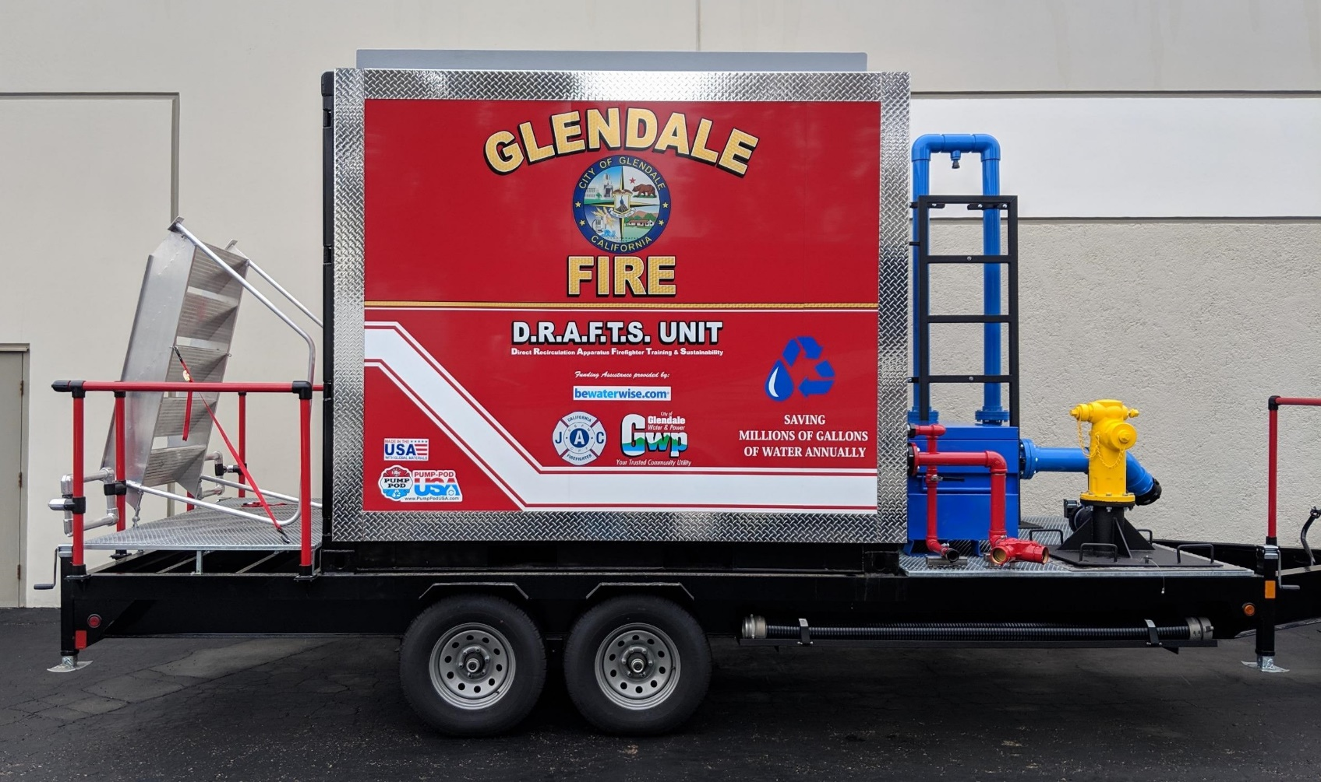

Approx. Gross Weight (Empty): 9,300 lbs. Example: How Artwork has been applied on previous Units.

DIRECT RECIRUCLING APPARATUS FIREFIGHTER TRAINING & SUSTAINABILITY UNIT

Rear Bulkhead Wall & Interior Features:
- Galvanized Diverter Screen mounted to Aluminum Frame (Optional Target can be mounted)
- Folding Aluminum Step on outside (Ladder step welded to Inside of Bulkhead Wall)
6 Welded Fire Hose & Nozzle Plates in 2.5” Ss Nipples Capped with 2.5” NH Fittings (Aluminum)
1 200 PSI Pressure Relief Valve for FDC Plumbing (Red)
1 1 ½” Valve, the same as if they were opening of Interior Standpipe on2nd or 3rd floor (Red)
(Connected to FDC Siamese with In-line 90⁰ Fittings to provide for the equivalent of
150’of resistance/ friction loss)

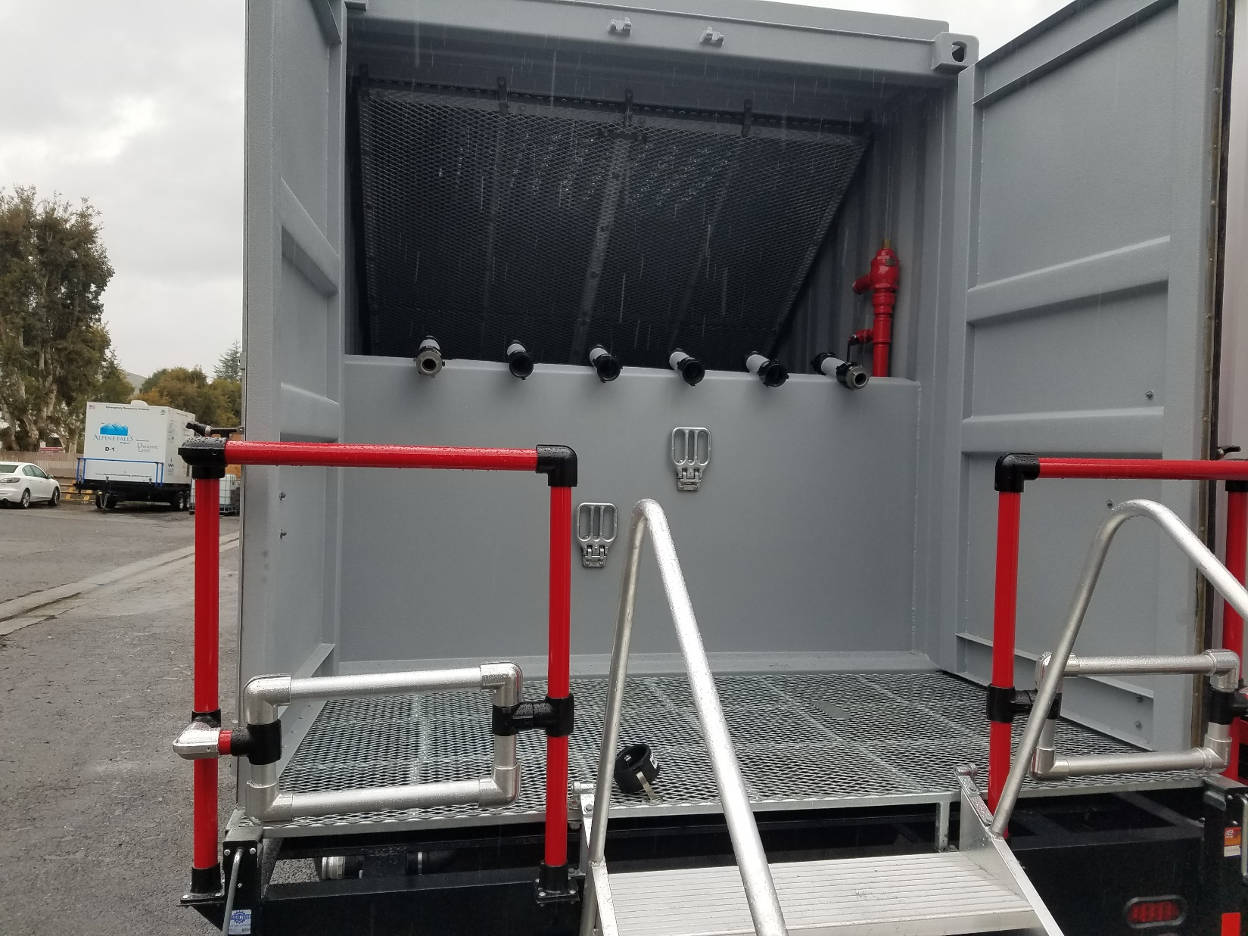

Front:
- Safety Rail with folding Aluminum Step at front of Deck
- 6” Horizontal Draft Port (Blue) with Butterfly Valve and 6” FNH Double Swivel Fitting (Alum.)
- 6” Vertical Riser Draft Training Riser per our discussion, (for a portion of annual pump testing)
1 2 ½” Valve with NH fitting - Make-up Water (using an Auto-Fill with Float) - Right side
1 Powder Coated Blue Parts Box
1 12 Volt Electromechanical Water Meter with Totalizer with 12 Battery & Conditioner w/ Plugin.
1 Portable Hydrant with Stainless Steel deck plate to secure to unit to the deck during transport.
1 (3) Port FDC with 2 ½”Clappered Snoots w/ working 3rd Story Stand pipe valve with 200 PSI PRV.
(Plumbed to series of 90 degree fittings Providing for 150’ of Line Restriction / friction loss.

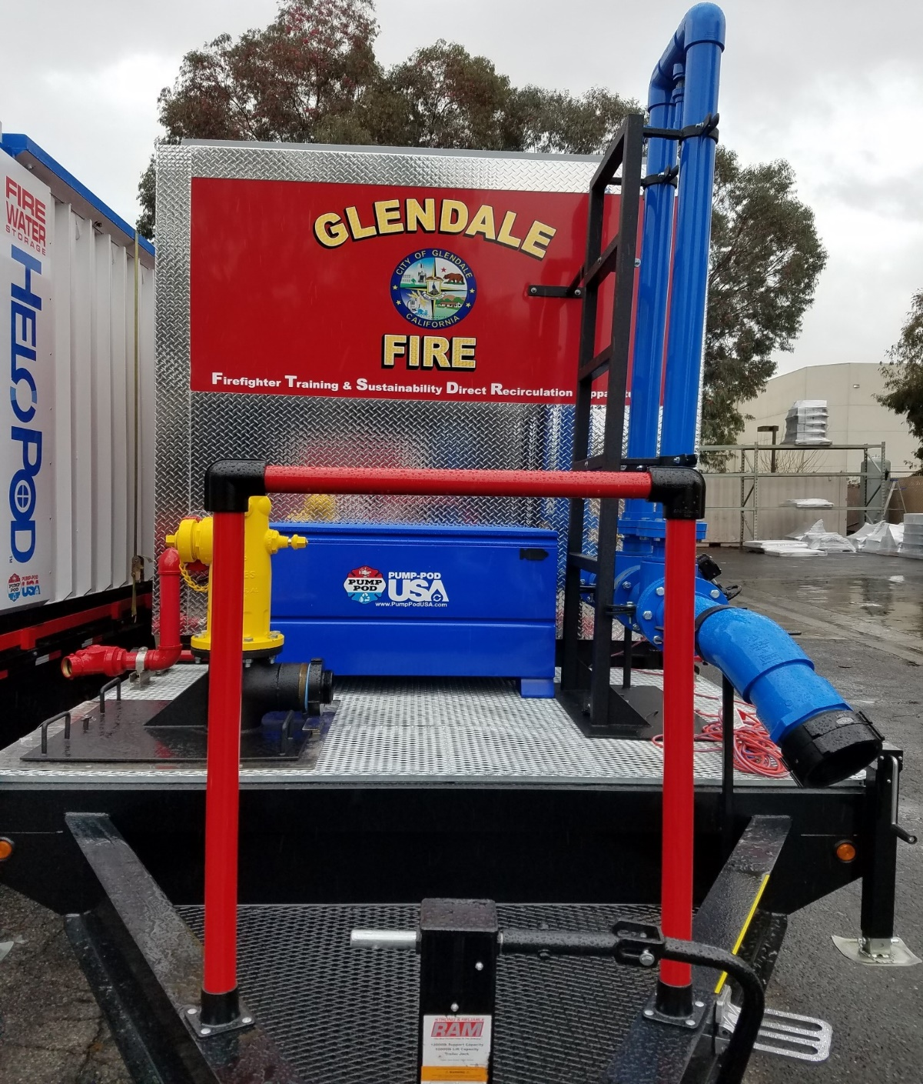

Standard Items & Features Included:
1 Portable Wet Barrel (DB) Customized Hydrant 6” Supply (4”, 4 ½” or 5” reducer NH Fitting) in 2 or 3 Ports
(3) Port FDC Connections – Plumbed with (3) 2 ½” Brass Clappered Snoots
Non-skid flooring welded on Rear deck level with Pod Floor with aluminum heavy duty non-skid decking.
Non-skid flooring welded on Front End Deck with expanded & raised Galvanized steel.
Powder Coated Front End Safety Rail with Aluminum Folding Step
Rear Stairs – Folding Aluminum with Web Strap Set for transport. Upper Handles coated with Rhino Liner.
Powder Coated Rear Safety Railing -
Aluminum Speed Rail Hose Guides on each side of Stairs (Protects Hoses & keeps hose off Stairs for Safety)
3” Floor Drain – Knife dump valve with Cam Fitting and 25’ of Lay Flat Drain Hose
Interior of Apparatus sprayed with watertight Rhino Liner protective coating for containment and durability.
Multi-layer Galvanized Expanded Steel Deflector Screen secured to Aluminum Frame.
Exterior Powder Coated Panel Siding with aluminum diamond plate trim. Artwork / Signage using a UV Wrap.
All Ball Valve Handles coated with Black Rhino Liner protective coating
Custom Heavy-Duty dual axle Trailer for Pump-Pod DRAFTS Unit (Painted Black)

Optional Items & Features
5’ x 5’ Galvanized Roof Target
Deflector Screen Target(s) - Bolted Swing Plates coated with Yellow Rhino Liner “type coating”
Additional - Portable Wet Barrel Customized Jones Hydrant (DB 4” x 2 1/2”, DB 4” x 2 ½” x 2 ½”)
Pump Testing Manifold (5) 3” Clappered Snoots for up to 2,000 GPM
Fire Hose Roller (Inserted when needed into Hitch Receiver – welded on either side of Rear Portion of Trailer

Warranty
15 Year Limited Warranty (See Warranty Document)

Repairs and Service of Units
Any Warranted Repairs or Non-Preventive Maintenance Service items covered by the warranty, will be performed by PumpPodUSA personnel or designated vendor. Written Notice with photographs documenting the Repair / Service Item in question shall be sent to PumpPodUSA in a timely manner from the Fire Department Fleet Services. Once PumpPodUSA reviews the issue they will decide on the course of action:
- Local Vendor - Dispatched by PumpPodUSA… (If Item is not completed by Vendor - Refer to Option #2)
- PumpPodUSA personnel will be dispatched to inspect and perform Repairs or Service on-site.
- If Repair & Service Item(s) can’t be completed on-site the Unit will be transported to the factory at the manufactures time and expense. Once Repair / Service are completed it will be returned back to Fire Department at manufactures expense.
- Fire Department Fleet representative will confirm Item in question was completed to Departments satisfaction must be signed off at time of delivery.

Mobile DRAFTS Unit Quote July 30, 2024

Salinas Fire Department Quote #: 24-0730SFDMDU-01
Pump-Pod / DRAFTS Unit | Specifications: | Descriptions | Unit Price:
(1) Mobile –  Approx. 2,100 Gallons | See the Following List:  Mobile Base Model | Mobile DRAFTS Unit  (see specifications above) | $104,575.00
Stenciling & Artwork Signage Wrap | Seals, Shields & Logos - Digital files provided by FD | Wrap Designed, Printed and Applied by PPUSA | Included
Diffuser Screen | Expanded Stainless Steel Screen | Secured to Aluminum Frame | Included
Bulkhead Inside Rear Door | (1) Step Outside of Bulkhead | (1) Step on Inside of Bulkhead | Included
Welded to Atop of Bulkhead | (6) – 2.5” Ss Nozzle Tubes | 2.5” NH Fittings on each Nozzle Tubes | Included
Front - Right Hand Side | (1) x 2.5” standard valve w/ female NH | Engine Pump Re-Circulation &  Quick-Fill Connection | Included
 | 6” Butterfly Valve on Primary Horizontal Drafting Connection | 6” FNPT to 6” FNH Dbl. Swivel Fitting  W /6” MNST x 4.5” FNh Swivel Reducer | Included
 | On vertical on Draft Riser –  Mat. Sched. 80 PVC | 6” FNPT to 6” MNH Fitting  Convert from Pipe to Fire Hose Threads  1” Bleeder Valve on Riser | Included
Front - Left Hand Side | (1) x 1.5” standard valve w/ auto-refill float inside | Make-up Water  1.5”FNPT x 1.5” MNH Fitting | Included
 | 3 Port FDC 4” x with (3) 2.5” Brass Clappered Snoots with  Pressure Relief Valve | Plumbed to fittings inside providing 150’ of Line Restriction & Friction loss and simulated Standpipe Hydrant | Included
Flexible Suction Hoses | 2- 6” Hoses 10’ in Length | 6” Diameter with NH Threaded Fittings | Included
1 Custom Portable Hydrant | DB 4 ½” x 2 ½” x 2 ½” | 6” Intake reduced to 4 1/2” FNH Swivel | Included
Electro-Mech. Water Meter | Electro-Mech. Water Meter | 12 Volt Battery with Conditioner | Included
Roof Target 5’ x 5’ Galvanized | Inset into Roof top for Drainage | Inset into Roof to act like funnel | Included
Swinging Nozzle Flow Targets | Powder coated Stainless Steel | Mounted to Diffuser Screen | Included
Tool/ Parts Box | Blue Powder coat |  | Included
Base Model Total: |  |  | $104,575.00
Accessories / Options:
Pump Test Assembly: | Pump Test Manifold & Assembly |  | $3,620.00
Addl. Portable Hydrant: | 3 Port Portable Hydrant |  | $4,680.00
Add-on & Options Sub-Total: |  |  | $8,300.00
Sub-Total before Sales Tax: |  |  | $112,875.00
Sales Tax: | Zip Code: 93901 | 9.25 % Sales Tax | $10,440.94
Total after Sales Tax: |  |  | $123,315.94
On-Site Training & Delivery: | Provided by PumpPodUSA | Training & Delivery | $1,650.00
Grand Total: |  |  | $124,965.94
Payment Installments: Please make the checks payable to:
$50,000 at time of issued Purchase Order PumpPodUSA
$74,965.94 due upon Delivery, Acceptance & Training 3850 Royal Ave., Suite B
Simi Valley – CA – 93063
Quote Valid for 30 days: due to volatile Steel & Raw Materials Costs

