DATE: DECEMBER 3, 2024
DEPARTMENT: FINANCE
FROM: SELINA ANDREWS, FINANCE DIRECTOR
TITLE: TECHNICAL ADJUSTMENTS FOR REMAINING UNENCUMBERED AMERICAN RESCUE PLAN ACT FUNDS

RECOMMENDED MOTION:

A motion to approve a resolution:

- Authorizing the City Manager to reappropriate any unencumbered ARPA project funding to the General Fund.

- Authorizing the City Manager to appropriate general funds to unencumbered ARPA projects in an amount not to exceed the previously approved project amount.

EXECUTIVE SUMMARY:

City Council allocated appropriations to nineteen (19) eligible projects through the use of American Rescue Plan Act (ARPA) funding. The projects were consistent with the intent of the Act and in alignment with previous Council guidance. In addition, Council considered the multiple needs of the Salinas community in terms of equitable continuation of City services, infrastructure,
investments in water and sewer, and homeless support services. At this time, staff is providing an update and recommendations to ensure encumbrance deadlines are met and projects continue to move forward.

BACKGROUND:

On August 6, 2024, staff provided an update on the nineteen ARPA projects previously identified by Council and proposed certain ARPA funding reallocations. Council approved the reallocations and projects continued to move forward.

On September 24, 2024, staff provided another ARPA projects update to City Council and while there were no reallocations recommended at the time, Staff requested City Manager authority to reallocate funding as appropriate within the different projects identified with ARPA funding.

The City received its first allocation of ARPA funding on May 19, 2021 and the second on June 18, 2022. Per the federal guidelines issued for ARPA, local governments are required to obligate all ARPA funds (e.g., encumber funding through the issuance of contracts/purchase orders) by December 31, 2024, and to expend all ARPA funds by December 31, 2026. A number of the community and economic recovery workstreams were anticipated to be spent over a multi-year period. Of the $51.6 million received ARPA funding, a remaining amount of $27.5 million is included in the FY 2024-25 Budget. While the City has made considerable progress in this effort, a total of $7.3 million remain unencumbered as of November 13, 2024 (based on expenditures at November 13, 2024). The table below identified the list of projects and remaining unencumbered amounts.

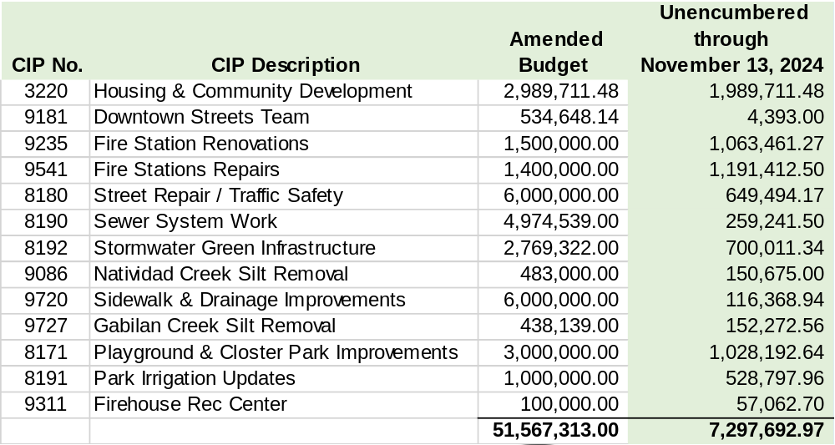

While it is anticipated that much of the remaining balance will be encumbered, with the Federal deadline approaching and to ensure that the City does not have to return any of the ARPA funds, in the abundance of caution staff now seeks authority for the City Manager to reallocate ARPA funding to other eligible uses. Additionally, staff is also requesting City Manager authority to appropriate general funds to certain previously approved ARPA projects to ensure that those projects can continue moving forward if and as needed.

CEQA CONSIDERATION:

Not a Project. The City of Salinas has determined that the proposed action is not a project as defined by the California Environmental Quality Act (CEQA) (CEQA Guidelines Section 15378).

CALIFORNIA GOVERNMENT CODE §84308 APPLIES:

No.

STRATEGIC PLAN INITIATIVE:

The projects and programs funded by the Salinas Recovery Plan under the American Rescue Plan
Act (ARPA) of 2021 achieves the Council 2022-2025 Strategic Goals of Housing/Affordable
Housing, Infrastructure and Environmental Sustainability, Public Safety, Youth and Seniors, and
Effective and Culturally Responsive Government.

DEPARTMENTAL COORDINATION:

This staff report has been coordinated with the City Manager’s Office, Finance Department,
Community Development, Fire, Public Works, and Library & Community Services.

FISCAL AND SUSTAINABILITY IMPACT:

Fund | Appropriation | Appropriation  Name | Total Appropriation | Amount for recommendation | FY 24-25 Operating Budget Page | Last Budget Action (Date, Resolution)
1100 | TBD | TBD | TBD | TBD | N/A | N/A

ATTACHMENTS:

- Resolution

