RESOLUTION NO. ______ (N.C.S.)
A RESOLUTION approving Budget adjustments and SUPPLEMENTAL APPROPRIATIONS to the FISCAL YEAR 2022 operating and capital budgets for the City of Salinas

WHEREAS, on June 8, 2021, the Salinas City Council adopted the Fiscal Year 2022 Operating and Capital Budgets; and

WHEREAS, on March 8, 2022 the City Council met and reviewed the mid-year budget and considered staff’s recommended budget adjustments.

NOW, THEREFORE, BE IT RESOLVED by the Council of Salinas, that the Council hereby approves supplemental appropriations of up to the following amounts for Fiscal Year 2022:

General Fund:

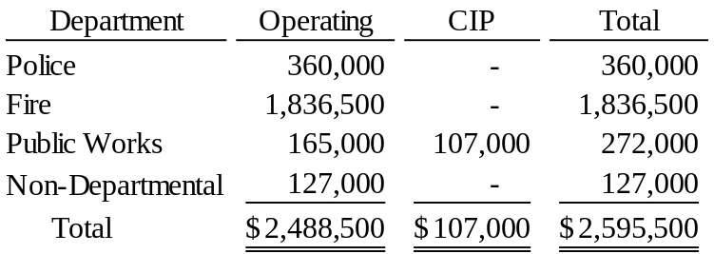

All other Funds:

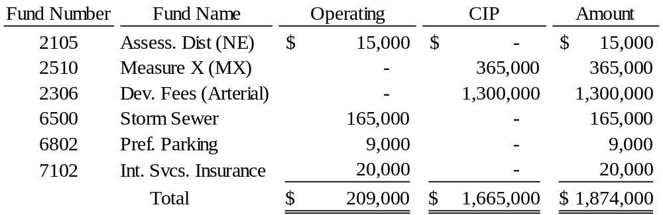

See attached Exhibit A for more details.

PASSED AND APPROVED this 8th day of March, 2022, by the following vote:

AYES:

NOES:

ABSENT:

ABSTAIN:

APPROVED:

______________________________________
Kimbley Craig, Mayor

ATTEST:

______________________________________
Patricia M. Barajas, City Clerk

