LICENSE AGREEMENT

A Portion of 282 East Alisal Street, Salinas, California

This License Agreement is made and entered into this 20th day of August 2024, by and between the City of Salinas, a California charter city and municipal corporation hereinafter called "the City," and Downtown Streets, Inc, a California non-profit corporation hereinafter called “Downtown Streets, Inc.” The City and Downtown Streets, Inc., may collectively be referred to herein as “the Parties.”
RECITALS
WHEREAS, the City is the owner of that real property located at 282 East Alisal Street, in the city of Salinas, California, County of Monterey, (Assessor’s Parcel Number 003-041-031-000) (hereinafter the “Property”); and
WHEREAS, the City is currently leasing a portion of the Property (approximately 0.7 acres in size), occupied by an existing self-service car and pet wash “the Premises”, said Premises being the entirety of the Property except for the westernmost 30 feet, which is occupied by a right-of-way, as more particularly described in Exhibit C; and
WHEREAS, Downtown Streets, Inc., has requested space for a staging area for the purpose of storage of equipment and materials in a storage shed in support of Downtown Streets, Inc.’s Alisal Commercial Corridor Cleanup Program services under Capital Improvement Project No. 9246; and
WHEREAS, City has identified space on the property owned by the city and located at 282 East Alisal Street of which the City will make a portion available to Downtown Streets, Inc., for the purposes described above; and
WHEREAS, the current Lessee has granted the City permission to License approximately 450 s.f. of space to Downtown Streets, Inc., who is entering into a contract for services concurrently on August 20, 2024, pursuant to which Downtown Streets, Inc., will perform the Alisal Commercial Corridor Cleanup Program services as part of the Alisal Vibrancy Plan (Capital Improvement Project No. 9246); and
NOW THEREFORE, this License Agreement is entered into upon the following terms and conditions:
TERMS
- Grant of License. The City hereby grants to Downtown Streets, Inc., an exclusive, temporary, and revocable License to use approximately 450 square feet of Licensed Space located at 282 East Alisal Street, as more particularly described in the attached “Exhibit A” (the “Licensed Space”) for the term set forth in section 3.

2. Purpose of License; Use of Licensed Space. The sole purpose of this License Agreement is to allow temporary storage and movement to and from the Licensed Space of equipment and materials, in support of Downtown Streets, Inc.’s Alisal Commercial Corridor Cleanup Program services under Capital Improvement Project No. 9246. Access to and use of the Licensed Space shall be put to no other use by Downtown Streets, Inc., or any of its subcontractors, sublicensees, officers, employees, agents, or representatives or any of their officers, employees, agents, or representatives. Neither Downtown Streets, Inc., nor any of its subcontractors, sublicensees, officers, employees, agents, or representatives nor any of their officers, employees, agents or representatives shall use the Licensed Space other than in a careful and proper manner and will adequately maintain the Licensed Space and all improvements thereon (if any) in the same physical condition as of the Commencement Date as defined below, making any and all replacements and repairs necessary during the term of this License to keep the Licensed Space in the same physical condition as of the Commencement Date; subject however, to normal wear and tear and as may be otherwise stipulated in this agreement. Downtown Streets, Inc., covenants and agrees that it shall never at any time suffer, permit, or allow any nuisance to be maintained upon all or any part of the Licensed Space nor any mechanic's, materialmen's, or laborer's liens to attach to said property.

3. Term. The term of this License Agreement for the use of the Licensed Space shall commence on August 6, 2024 (the “Commencement Date”) and expire on June 30, 2025 (the Termination Date”). Downtown Streets, Inc., shall have the option to extend this License Agreement by an additional one month, to July 31, 2025, by providing written notice to the City at three (3) days prior to the expiration date. This License Agreement may only be further extended upon the express written consent of the City.

Upon the expiration or the earlier termination of this License, Downtown Streets, Inc., shall peaceably vacate the Licensed Space and any and all improvements located thereon and deliver the same to the City in at least as good a condition as it was delivered to Downtown Streets, Inc., on the Commencement Date, reasonable wear and tear and casualty excepted.

4. License Fee. Downtown Streets, Inc., may utilize the Licensed Space for a $1.00 fee beginning on the Commencement Date and continuing through the Termination Date. This Licensed Space is integral for the regular cleanup of the Alisal commercial corridors to serve as a staging area for the purpose of storage of equipment and materials in a storage shed in support of Downtown Streets, Inc.’s Alisal Commercial Corridor Cleanup Program services under Capital Improvement Project No. 9246.

5. Condition of Licensed Space. The Licensed Space is Licensed to Downtown Streets, Inc., on an “As-Is” basis and the City has no obligation for maintenance, repair, improvement, or alteration of or to the properties either during the term of this License Agreement. Except as otherwise set forth in this License Agreement, Downtown Streets, Inc., is not required to repair any pre-existing conditions on the Licensed Space. Notwithstanding the preceding, Downtown Streets Inc.’s inspection of the Licensed Space has been limited to a visual inspection of the surface conditions. Consequently, Downtown Streets Inc.’s acceptance of the Licensed Space is limited to the surface conditions and Downtown Streets, Inc., is not responsible for sub-surface conditions of the Licensed Space. The City may access the Licensed Space for general maintenance, if deliberately unattended by Downtown Streets, Inc.

6. Structures. No structures, other than the approved storage shed for the Alisal Cleanup Program, shall be placed on or constructed upon the Licensed Space, except as otherwise authorized in advance and in writing by the City. As used in this paragraph, “structures” shall not be construed to mean the equipment (including incidental equipment) necessary to perform any of the authorized uses of the Licensed Space.

7. Laws and Ordinances. Downtown Street, Inc., shall comply with all statutes, ordinances, regulations, and requirements of all governmental entities, both federal and state and county or municipal relating to Downtown Streets, Inc.’s use and occupancy of the Licensed Space whether those statutes, ordinances, regulations, and requirements are now in force or are subsequently enacted.

8. Assessments. This License may create a taxable possessory interest, together with any other taxes or assessments imposed against Downtown Streets, Inc., or the activities of Downtown Streets, Inc., shall be paid by Downtown Streets, Inc., before they become delinquent.

9. Utilities. This License does not include the furnishing of gas, water, electricity, telephone service, garbage pickup and disposal, and other public utilities to the Licensed Space during the term of this License.

10. Indemnification. Downtown Streets, Inc., shall indemnify, defend, and hold the City and its officers, employees, agents, and representatives harmless from and against any and all liability, claims, suits, actions, damages, and causes of action arising out of any personal injury, bodily injury, loss of life, or damage to any property, or violation of any relevant federal, state or municipal law or ordinance, or other cause in connection with the City’s grant of this License and Downtown Streets, Inc., and any of its sublicensees, officers, employees, agents or representatives’ use or occupancy of the Licensed Space pursuant to such License, except for any such claim arising from the acts, omissions, comparative negligence, or willful misconduct of the City, its officers, employees, agents or representatives. This indemnification and hold harmless clause shall apply whether or not such insurance policies shall have been determined to be applicable to any of such damages or claims for damages and shall survive the expiration or the earlier termination of this License Agreement.

11. Insurance. Downtown Streets, Inc., shall maintain, at its own cost an expense, the insurance specified in Attachment B.

12. Hazardous Substances. Downtown Streets, Inc., shall not use any portion of the Licensed Space for the storage or use of flammable or hazardous substances or underground storage tanks. Downtown Streets, Inc., shall be solely responsible for the cleanup and remediation of any spill or discharge or any hazardous substances including, but not limited to, gasoline, diesel and oil from such vehicles and equipment. As required by law, Downtown Streets, Inc. shall immediately notify the City in writing of any material release of hazardous substances and of any hazardous substances that have come to be located on or beneath the Licensed Space.

12. Removal of Personal Property; Restoration of Licensed Space. At the expiration or the earlier termination of this License Agreement, Downtown Streets, Inc., shall at its sole cost and expense remove all items of personal property and all improvements placed upon the Licensed Space and shall surrender the Licensed Space at termination of the License in as good order, state, and condition as the same shall be on the Commencement Date, except as related to ordinary wear and tear thereof and damage by fire, the elements, and acts of God.

13. Assignment and Subletting. Downtown Streets, Inc., shall not encumber, assign, or otherwise transfer this License, any right or interest in this License, or any right or interest in the Licensed Space or any improvements that may now or hereafter be constructed or installed on the Licensed Space to any other person or entity without first obtaining the express written consent of the City.

14. Termination. Either Party may terminate this License Agreement for any reason or no reason by giving written notice of termination to the other Party no less than three (3) days in advance of the intended date of such termination. Any property remaining on the site following this time shall be deemed to be abandoned and the City may take possession or dispose of said property as it deems appropriate. Under no circumstance shall Downtown Streets, Inc., be eligible for any reimbursement or refund of already performed services or paid License Fees.

15. Successors and Assigns. Except as otherwise provided for herein, the parties expressly agree that, subject to the terms of this License, all terms and conditions of this License shall extend to and be binding upon or inure to the benefit of the heirs, executors, administrators, personal representative, assigns and successors in interest of both the respective parties hereto.

16. Non-Discrimination in Use and Availability. Downtown Streets, Inc., shall not discriminate on the basis of a person’s place of residence, their race, religion, color, national origin, age, physical or mental handicap or disability, medical condition, marital status, sex, or sexual orientation, against any participant in, recipient of, or applicant for any services or programs provided by at the Licensed Space. Downtown Streets, Inc., shall comply with all applicable federal, state, and local laws, policies, rules, and requirements related to equal opportunity and non-discrimination in the provision of any services or programs offered at the Licensed Space.

17. Accident Reports. Downtown Streets, Inc., shall immediately report to the City in writing any accident causing or reasonably estimated to have caused more than one thousand dollars ($1,000) worth of property damage or any serious injury to person or to property that occurs on or in connection with the Licensed Space. This written report shall contain the names and addresses of the parties involved, a statement of the circumstances, the date and the hour, the names and the addresses of any witnesses, and any other pertinent information.

18. Notices.
City of Salinas
City Manager
City of Salinas
200 Lincoln Avenue
Salinas, California 93901

With a Copy to:

City Attorney
City of Salinas
200 Lincoln Avenue
Salinas, California 93901

Downtown Streets, Inc.
Julie Gardner, CEO
1671 The Alameda, Suite 301
San Jose, CA 95126

[SIGNATURES APPEAR ON FOLLOWING PAGE]
IN WITNESS WHEREOF, the parties hereto have caused this License Agreement to be executed as of the date first written above.

CITY OF SALINAS DOWNTOWN STREETS, INC.

____________________________ ________________________________
Rene L. Mendez Julie Gardner
City Manager Chief Executive Officer

APPROVED AS TO FORM:

____________________________
Christopher A. Callihan
City Attorney

Exhibit A

The Licensed Space is approximately 450 square feet, a portion of the property at 282 East Alisal Street, Monterey County Assessor’s Parcel Number (APN) 003-041-031-000 (the “Property”) A map showing the approximate boundaries of the Licensed Space is below – in the event of a conflict between the text and the map, the text shall control.

Use of the licensed space shall not to impede access to the existing waste bin for the collection of garbage.

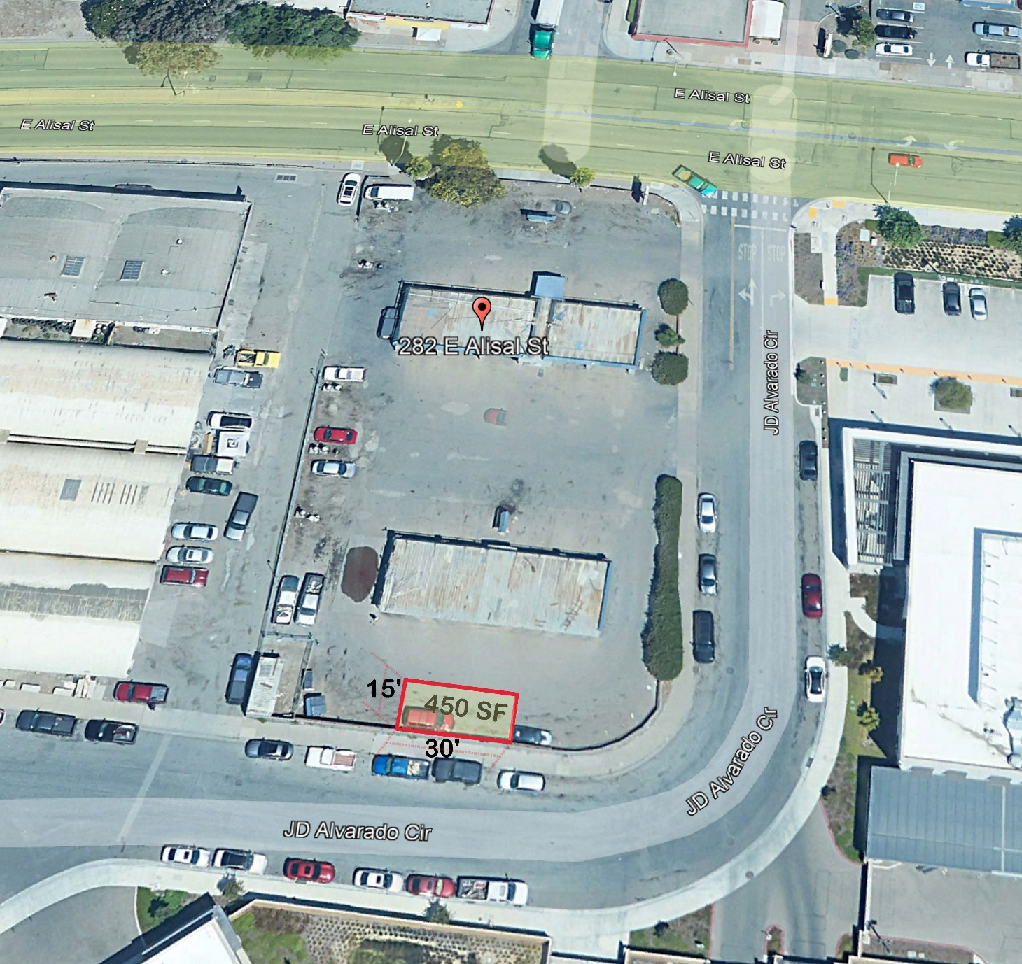

Exhibit B
INSURANCE REQUIREMENTS
BES shall procure and maintain for the duration of the contract insurance against claims for injuries to persons or damages to property which may arise from or in connection with the clearing of the Licensed Space and Subcontractor’s permitted use of the Licensed Space as provided in the License.

Minimum Scope and limit of Insurance

Coverage shall be at least as broad as:
- Commercial General Liability (CGL): Insurance Services Office Form CG 00 01 covering CGL on an “occurrence” basis, including products and completed operations, property damage, bodily injury, and personal & advertising injury with limits no less than $2,000,000 per occurrence. If a general aggregate limit applies, either the general aggregate limit shall apply separately to this project/location (ISO CG 25 03 or 25 04) or the general aggregate limit shall be twice the required occurrence limit.
- Automobile Liability: ISO Form Number CA 00 01 covering any auto (Code 1), or if BES has no owned autos, hired, (Code 8) and non-owned autos (Code 9), with limit no less than $1,000,000 per accident for bodily injury and property damage.
- Workers’ Compensation: as required by the State of California, with Statutory Limits, and Employer’s Liability Insurance with limit of no less than $1,000,000 per accident for bodily injury or disease.
- Property insurance: against all risks of loss to any of BES’s personal property, improvements, or betterments at full replacement cost with no coinsurance penalty provision.
If BES maintains broader coverage and/or higher limits than the minimums shown above, the City requires and shall be entitled to the broader coverage and/or the higher limits maintained by BES. Any available insurance proceeds in excess of the specified minimum limits of insurance and coverage shall be available to the City.
Other Insurance Provisions
The insurance policies are to contain, or be endorsed to contain, the following provisions: N/A
Additional Insured Status
The City, its officers, officials, employees, and volunteers are to be covered as additional insureds on the CGL policy. Additional insured status can be provided in the form of an endorsement to BES’s insurance (at least as broad as both ISO forms CG 20 10 and CG 20 37).
Primary Coverage
For any claims related to this contract, BES’s insurance coverage shall be primary coverage at least as broad as ISO CG 20 01 04 13 as respects the City, its officers, officials, employees, and volunteers. Any insurance or self-insurance maintained by the City, its officers, officials, employees, or volunteers shall be excess of BES’s insurance and shall not contribute with it.

Notice of Cancellation
Each insurance policy required above shall provide that coverage shall not be canceled, except with notice to the City in accordance with the policy provisions.
Waiver of Subrogation
BES hereby grants to City a waiver of any right to subrogation which any insurer of BES may acquire against the City by virtue of the payment of any loss under such insurance. BES agrees to obtain any endorsement that may be necessary to affect this waiver of subrogation, but this provision applies regardless of whether or not the City has received a waiver of subrogation endorsement from the insurer.
Self-Insured Retentions
Self-insured retentions must be declared to and approved by the City. The policy language shall provide, or be endorsed to provide, that the self-insured retention may be satisfied by either the named insured or City. BES shall have the right to self-insure with respect to the insurance requirements required under this Agreement. BES’s self-insurance program is in full force and effect and in compliance with and subject to all the terms, agreements, covenants, conditions, and provisions of this agreement.
Acceptability of Insurers
Insurance is to be placed with insurers with a current A.M. Best’s rating of no less than A:VII, unless otherwise acceptable to the City.
Verification of Coverage
BES shall furnish the City with original certificates and amendatory endorsements, or copies of the applicable policy language effecting coverage required by this clause. All certificates and endorsements are to be received and approved by the City before work commences. However, failure to obtain the required documents prior to the work beginning shall not waive BES’s obligation to provide them. The City reserves the right to require complete, certified copies of all required insurance policies (except that information proprietary to BES may be redacted), including endorsements required by this Exhibit B during the term of the License.

