PURCHASE AND SALE AGREEMENT
This PURCHASE AND SALE AGREEMENT (“Agreement”) is dated as of January 11, 2022 (“Effective Date”) and is being entered into by and between the CITY OF SALINAS, a California municipal corporation and charter city (“Seller”), and CITY OF GONZALES, a California municipal corporation (“Buyer”), for the acquisition by Buyer of certain real property described below.
RECITALS
A. Seller is the owner in fee of that certain real property consisting of approximately 0.3168 acres of land area in the City of Gonzales, County of Monterey, State of California, and which is otherwise known as Monterey County Assessor’s Parcel Number 223-061-002-000, as such is more precisely defined in Exhibit “A” (“Property”). The Property was historically used for equipment to provide navigational assistance to aircraft, but technological advancements have rendered such equipment unnecessary and the equipment has been removed.
B. Seller is the owner of certain rights conveyed by an easement for roadway and public utility purposes and an easement for aerial navigation purposes, both of which are located on or near the Property, as such are more precisely defined in Exhibit “B” (“Easements”). These Easements are not, nor are expected to be, necessary for the Seller’s municipal purposes now or in the future.
C. Buyer operates a municipal wastewater treatment facility adjacent to the Property. Buyer intends to expand the existing facility and desires to purchase the Property to use in the development of that project.
D. The Seller has authority to convey the Property to the Buyer pursuant to Art. XI, Sec. 5 of the California Constitution, the City’s Charter, Sections 37350 and 37351 of the Government Code, and Chapter 12 of the Salinas Municipal Code. The City Council, in approving this Agreement, finds and determines, among other things, that the sale of the Property pursuant to the terms of this Agreement will serve the public convenience, necessity, or welfare.
NOW, THEREFORE, Seller and Buyer hereby agree as follows:
- Agreement to Sell and Purchase. Seller agrees to sell the Property to Buyer and Buyer agrees to purchase the Property from Seller upon the terms and for the consideration set forth in this Agreement.
- Purchase Price. The purchase price of the Property (“Purchase Price”) is Eighteen Thousand Nine Hundred Forty-Six dollars ($18,946.00). Further, Buyer agrees to reimburse Seller $2,000 for its costs to update the Airport Layout Plan (“ALP”).
- Conveyance of Title and Possession. Seller agrees to convey by Deed (defined below) to Buyer all of Seller’s title and interest in and to the Property. Seller makes no representations, guarantees, or warranties regarding Buyer’s ability to develop the Property as desired. Buyer, at its own expense, shall be responsible for the preparation of materials (such as maps and legal descriptions) as well as the submittal of any applications or other documents necessary to effectuate the transfer of the land and/or subdivide the land pursuant to the Subdivision Map Act.
- Title Insurance Policy. Escrow Holder shall, following recording of the Deed, provide Buyer with a standard owner’s CLTA (or extended coverage ALTA, at the request of Buyer) policy of title insurance in the amount of the Purchase Price, issued by the Title Company, together with any endorsements and additional coverage reasonably requested by Buyer, showing fee simple title to the Property vested in Buyer, subject only to the printed exceptions and stipulations in the policy. Title charges shall be paid by Buyer.
- Escrow. Buyer and Seller shall open an escrow (“Escrow”) in accordance with this Agreement with Chicago Title Company (“Escrow Holder”). This Agreement, together with the escrow instructions prepared by Escrow Holder and executed by Buyer and Seller, constitute the joint escrow instructions of Buyer and Seller, and the Escrow Holder to whom these instructions are delivered is hereby empowered to act under this Agreement. The parties hereto agree to do all acts necessary to close this Escrow on or before the Closing Date (defined below); provided, however, neither Buyer nor Seller shall be obligated to waive any rights, conditions or contingencies under this Agreement in order to close the Escrow.
- Delivery of Deed and Purchase Price. Seller shall execute and deliver into the Escrow a Grant Deed (“Deed”) to Buyer, in substantially the form attached hereto as Exhibit “C” and incorporated herein. Buyer agrees to deposit the Purchase Price upon demand of Escrow Holder, not fewer than one (1) business day prior to the date set for the Closing. Buyer and Seller agree to deposit with Escrow Holder any additional instruments as may be necessary to complete this transaction.
- Insurance. Insurance policies are not to be transferred, and Seller may cancel its own policies, if any, after close of escrow.
- Taxes. Escrow is not to be concerned with proration of Seller’s taxes for the current fiscal year. Seller is a public agency and therefore exempt from the payment of property taxes.
- Escrow Account. All funds received in the Escrow shall be deposited with other escrow funds in a general escrow account(s) and may be transferred to any other escrow trust account in any state or national bank doing business in the State of California. All disbursements shall be made by check from such account.
- Escrow Holder Authorization. Escrow Holder is authorized to, and shall:
- Fees, Charges and Costs. Pay and charge Buyer for Escrow fees, charges, and costs payable under Section 14.
- Disbursement. Disburse funds, record the Deed, and deliver the title policy to Buyer, when conditions of the Escrow have been fulfilled by Buyer and Seller.
- Close of Escrow. The terms “Close of Escrow,” “Close,” and “Closing,” if and where written in these instructions, shall mean the date the Deed and other necessary instruments of conveyance are recorded in the Official Records of the Monterey County Recorder (“Official Records”). Recordation of instruments delivered through this Escrow is authorized, if necessary or proper for the issuance of the policy of title insurance pursuant to Section 4 hereof.
- Time Limits. All time limits within which any matter specified is to be performed may be extended by mutual agreement of the parties. Any amendment of, or supplement to, any instructions must be in writing.
- Time of the Essence. Provided that the conditions set forth in this Agreement have been satisfied, the Closing shall occur on or before the date 45 days subsequent to the Effective Date (“Closing Date”). In the event the Closing does not occur on or before the Closing Date, either party that is not in default hereunder shall be entitled to cancel Escrow, terminate this Agreement, and the Escrow Holder shall return to the depositor thereof all documents, instruments, and monies which were deposited hereunder; provided, however, that if both parties have satisfied all requirements specified under this Agreement, including Section 17, by the Closing Date, then neither party shall have this right to terminate the Agreement pursuant to this Section. The foregoing shall not constitute an election of remedies for a non-defaulting party if the other party wrongfully fails to close Escrow.
- Escrow Fees, Charges and Costs. Buyer shall be responsible for and shall pay all transaction costs, including the applicable transfer taxes, if any, the cost of recording the Deed or any curative instruments, escrow fees, the costs associated with Buyer’s financing, if any, the cost of any title endorsements, and the cost of a CLTA standard coverage owner’s (or extended or ALTA, if desired by Buyer) title policy as described in Section 4. Each party shall pay its own legal fees.
- Tax Requirements. Escrow Holder shall prepare and file with all appropriate governmental or taxing authorities a uniform settlement statement, closing statement, tax withholding forms including an IRS 1099-S form, and be responsible for withholding taxes, if any such forms are provided for or required by law.
- Closing Statement. Seller instructs Escrow Agent to release a copy of Seller’s closing statement to Buyer, and Buyer instructs Escrow Agent to release a copy of Buyer’s closing statement to Seller.
- Conditions Precedent to Close of Escrow.
- Buyer’s Conditions Prior to Closing. Buyer’s obligation to complete the purchase of the Property is subject to the satisfaction or Buyer’s waiver in its sole and absolute discretion of each of the following conditions:
- Seller shall have delivered through Escrow an executed and recordable Deed sufficient to convey fee title to Buyer as set forth in Section 6 in full compliance with the Subdivision Map Act.
- Seller shall have delivered through Escrow executed and recordable Quitclaim Deeds (substantially in the form attached hereto as Exhibits “D-1,” “D-2,” and “D-3” and incorporated herein) sufficient to relinquish Seller’s interest in the Easements.
- Seller shall have delivered through Escrow such other documents as are necessary to comply with Seller’s obligations under this Agreement.
- Buyer shall have approved the condition of title to the Property and the Title Company shall have committed to deliver to Buyer a title insurance policy as required by Section 4 hereof at or immediately after the Closing.
- Buyer shall not have terminated this Agreement as otherwise specifically permitted by the provisions of this Agreement.
- Seller shall not be in default of any of its obligations under the terms of this Agreement, and all representations of Seller herein shall be true and correct.
- Seller’s Conditions Precedent to Closing. Seller’s obligation to complete the sale of the Property is subject to the satisfaction or Seller’s waiver in its sole and absolute discretion of each of the following conditions:
- Buyer shall have deposited with Escrow Holder immediately available funds in an amount equal to the Purchase Price and any other applicable charges as defined in Section 14.
- Buyer shall have deposited $2,000 with Escrow Holder to reimburse City for the estimated costs of updating its Airport Layout Plan (ALP).
- Buyer shall not be in default of any of its obligations under the terms of this Agreement, and all representations of Buyer herein shall be true and correct.
- The Seller shall not have terminated this Agreement as otherwise specifically permitted by the provisions of this Agreement.
- Permission to Enter on Premises. Seller agrees to grant to Buyer, or its authorized agents, permission to enter upon the Property at all reasonable times prior to Close of Escrow for the purpose of making necessary or appropriate inspections, tests, surveys, assessments and reports of the Property, at Buyer’s expense (“Tests”). Buyer shall indemnity, defend, and hold harmless Seller and its officers, directors, shareholders, partners, employees, agents, and representatives from and against all claims, liabilities or damages, and including expert witness fees and reasonable attorney’s fees and costs, caused by Buyer’s activities with respect to or arising out of such testing, inspection, or investigatory activity on the Property. If, prior to the Close of Escrow, Buyer disapproves of the condition of the Property after conducting its Tests, then Buyer may terminate this Agreement.
- Warranties, Representations, and Covenants of Seller. Seller hereby warrants, represents, and/or covenants to Buyer that:
  - Pending Claims. To Seller’s Actual Knowledge, there are no actions, suits, claims, legal proceedings, or any other proceedings affecting the Property or any portion thereof, at law, or in equity before any court or governmental agency, domestic or foreign.
  - Seller’s Title. Until the Close of Escrow, Seller shall not do anything which would impair Seller’s title to the Property or Buyer’s right of possession, development, or use of the Property after the Close of Escrow consistent with this Agreement, the Use Covenant and the Custodial Agreement.
  - Conflict with Other Obligation. To Seller’s actual knowledge, neither the execution of this Agreement nor the performance of the obligations herein will conflict with, or breach any of the provisions of any bond, note, evidence of indebtedness, contract, lease, covenants, conditions and restrictions, or other agreement or instrument to which Seller or the Property may be bound.
  - Authority. Seller has the full right, power, and authority to sell, convey, and transfer the Property to Buyer as provided herein and to carry out Seller’s obligations hereunder.
  - Bankruptcy. Seller is not the subject of a bankruptcy proceeding, and permission of a bankruptcy court is not necessary for Seller to be able to transfer the Property as provided herein.
  - Governmental Compliance. Seller has not received any notice from any governmental agency or authority alleging that the Property is currently in violation of any law, ordinance, rule, regulation or requirement applicable to its use and operation. If any such notice or notices are received by Seller following the date this Agreement is signed by Buyer, Seller shall, within ten (10) days of receipt of such notice notify Buyer; Seller then, at its option, may either elect to perform the work or take the necessary corrective action prior to the close of Escrow or refuse to do so, in which case Seller shall notify Buyer of such refusal and Buyer shall be entitled to either close Escrow with knowledge of such notice(s) or terminate this Agreement.
  - Right to Possession. No person, firm, partnership or corporation has or will have the right to possess the Property or any portion of it as of the Effective Date or the Close of Escrow.
  - Change of Situation. Until the Close of Escrow, Seller shall, upon learning of any fact or condition which would cause any of the warranties and representations in the section not to be true as of the Close of Escrow, immediately give written notice of such fact or condition to Buyer.
- Warranties, Representations, and Covenants of Buyer. Buyer hereby warrants, represents, and/or covenants to Seller that:
- Authority. Buyer is a California Limited Liability Corporation duly organized, validly existing and in good standing under the laws of the State of California; this Agreement and all documents executed by Buyer are and at the time of Close of Escrow will be duly authorized, executed and delivered by Buyer, are and at the time of Close of Escrow will be legal, valid and binding obligations of Buyer enforceable against Buyer in accordance with its respective terms.
- Bankruptcy. Buyer is not the subject of a bankruptcy proceeding.
- Change of Situation. Until the Close of Escrow, Buyer shall, upon learning of any fact or condition which would cause any of the warranties and representations in the section not to be true as of the Close of Escrow, immediately give written notice of such fact or condition to Seller.
- Condition of the Property.
- Hazardous Materials. As used in this Agreement, the term “Hazardous Materials” shall mean any substance, material, or waste which is or becomes, regulated by any local governmental authority, the County of Monterey, the State of California, any regional governmental authority, or the United States Government, including, but not limited to, any material or substance which is (i) defined as a “hazardous waste,” “extremely hazardous waste,” or “restricted hazardous waste” under Sections 25115, 25117 or 25122.7, or listed pursuant to Section 25140 of the California Health and Safety Code, Division 20, Chapter 6.5 (Hazardous Waste Control Law), (ii) defined as a “hazardous substance” under Section 25316 of the California Health and Safety Code, Division 20, Chapter 6.8 (Carpenter-Presley-Tanner Hazardous Substance Account Act), (iii) defined as a “hazardous material,” “hazardous substance,” or “hazardous waste” under Section 25501 of the California Health and Safety Code, Division 20, Chapter 6.95 (Hazardous Materials Release Response Plans and Inventory), (iv) defined as a “hazardous substance” under Section 25281 of the California Health and Safety Code, Division 20, Chapter 6.7 (Underground Storage of Hazardous Substances), (v) petroleum, (vi) friable asbestos, (vii) polychlorinated biphenyls, (viii) methyl tertiary butyl ether, (ix) designated as “hazardous substances” pursuant to Section 311 of the Clean Water Act (33 U.S.C. §1317), (x) defined as a “hazardous waste” pursuant to Section 1004 of the Resource Conservation and Recovery Act, 42 U.S.C. §§6901, et seq. (42 U.S.C. §6903) or (xi) defined as “hazardous substances” pursuant to Section 101 of the Comprehensive Environmental Response, Compensation, and Liability Act, 42 U.S.C. §§9601, et seq.
- Compliance with Environmental Laws. To the Seller’s actual knowledge, there are no Hazardous Materials on, under, or at the Property that would make the Property not otherwise in compliance with any applicable laws and governmental regulations including, without limitation, all applicable federal, state, and local laws pertaining to air and water quality, hazardous waste, waste disposal, and other environmental matters, including, but not limited to, the Clean Water, Clean Air, Federal Water Pollution Control, Solid Waste Disposal, Resource Conservation Recovery and Comprehensive Environmental Response Compensation and Liability Acts, and the California Environmental Quality Act, and the rules, regulations, and ordinances of the Seller of Salinas, the California Department of Health Services, the Regional Water Quality Control Board, the State Water Resources Control Board, the Environmental Protection Agency, and all applicable federal, state, and local agencies and bureaus.
- As Is Sale. Except as otherwise provided herein, the physical condition, possession and title of the Property is and shall be delivered from Seller to Buyer in an “as is” condition, with no warranty expressed or implied by Seller, including without limitation, the presence of Hazardous Materials or the condition of the soil, its geology, the presence of known or unknown seismic faults, or the suitability of the Property for the development purposes intended hereunder.

Except to the extent of the warranty and representation contained herein, Buyer hereby waives, releases and discharges forever Seller and its respective elected officials, employees, volunteers, directors, officers, agents and representatives, from all present and future claims, demands, suits, legal and administrative proceedings and from all liability for damages, losses, costs, liabilities, fees and expenses, present and future, arising out of or in any way connected with the condition of the Property, any Hazardous Materials on or under the Property, or the existence of Hazardous Materials contamination due to the generation of Hazardous Materials from the Property, however they came to be placed there, except that arising out of the gross negligence or willful misconduct of Seller or its respective elected officials, employees, volunteers, directors, officers, agents or representatives.

Buyer acknowledges that it is aware of and familiar with the provisions of Section 1542 of the California Civil Code which provides as follows:

“A general release does not extend to claims which the creditor does not know or suspect to exist in his or her favor at the time of executing the release, which if known by him or her must have materially affected his or her settlement with the debtor.”

Buyer hereby waives and relinquishes all rights and benefits which it may have under Section 1542 of the California Civil Code.
- Brokers. Buyer and Seller each represent to the other that no brokerage commission, finder’s fee or other compensation of any kind is due or owing to any person or entity in connection with this Agreement. Each party agrees to and does hereby indemnify and hold the other free and harmless from and against any and all costs, liabilities or causes of action or proceedings which may be instituted by any broker, agent or finder, licensed or otherwise, claiming through, under or by reason of the conduct of the indemnifying party in connection with this Agreement.
- Waiver, Consent and Remedies. Each provision of this Agreement to be performed by Buyer and Seller shall be deemed both a covenant and a condition and shall be a material consideration for Seller’s and Buyer’s performance hereunder, as appropriate, and any breach thereof by Buyer or Seller shall be deemed a material default hereunder by such breaching party. Either party may specifically and expressly waive in writing any portion of this Agreement or any breach thereof, but no such waiver shall constitute a further or continuing waiver of a preceding or succeeding breach of the same or any other provision. A waiving party may at any time thereafter require further compliance by the other party with any breach or provision so waived. The consent by one party to any act by the other for which such consent was required shall not be deemed to imply consent or waiver of the necessity of obtaining such consent for the same or any similar acts in the future. No waiver or consent shall be implied from silence or any failure of a party to act, except as otherwise specified in this Agreement. All rights, remedies, undertakings, obligations, options, covenants, conditions and agreements contained in this Agreement shall be cumulative and no one of them shall be exclusive of any other. Except as otherwise specified herein, either party hereto, after expiration of the Cure Period specified in Section 16 below without cure thereof, may pursue any one or more of its rights, options or remedies hereunder or may seek damages or specific performance in the event of the other party’s breach hereunder, or may pursue any other remedy at law or equity, whether or not stated in this Agreement.
- Attorney’s Fees. In the event any declaratory or other legal or equitable action is instituted between Seller, Buyer and/or Escrow Holder in connection with this Agreement then, as between Buyer and Seller, the prevailing party shall be entitled to recover from the losing party all of its costs and expenses, including court costs, reasonable attorneys’ fees, expert witness fees, and all fees, costs and expenses incurred on any appeal or in collection of any judgment.
- Notices. Any notice, request, demand, consent, approval or other communication required or permitted hereunder or by law shall be validly given or made only if in writing and delivered in person to an officer or duly authorized representative of the other party, or deposited in the United States mail, duly certified or registered (return receipt requested), postage prepaid, or delivered through another reasonably acceptable method, and addressed to the party for whom intended, as follows:
If to Seller: City of Salinas
200 Lincoln Avenue
Salinas, California 93901
Attention: Steven S. Carrigan, City Manager
With a copy to: City of Salinas
200 Lincoln Avenue
Salinas, California 93901
Attention: Chris Callihan, City Attorney
With a copy to: City of Salinas
200 Lincoln Avenue
Salinas, California 93901
Attention: Andrew Myrick, Economic Development Manager
If to Buyer: City of Gonzales
PO Box 647
Gonzales, CA 93926
147 Fourth Street
Attention: Rene Mendez, City Manager
Any party may from time to time, by written notice to the other, designate a different address which shall be substituted for that specified above. If any notice or other document is sent by mail as aforesaid, the same shall be deemed fully delivered and received forty-eight (48) hours after mailing as provided above.
- Breaches and Defaults. Subject to Enforced Delay, failure or delay by either party to perform any material term or provision of this Agreement (a “Breach”) following written notice and failure to cure as described hereafter constitutes a “Default” under this Agreement.

The nondefaulting party shall give written notice of any Breach to the party in Breach, specifying the Breach complained of by the nondefaulting party (“Notice of Default”). Delay in giving such Notice of Default shall not constitute a waiver of any Breach nor shall it change the time of Breach. Upon receipt of the Notice of Default, the party in Breach shall promptly commence to cure the identified Breach at the earliest reasonable time after receipt of the Notice of Default and shall complete the cure of such Breach not later than thirty (30) days after receipt of the Notice of Default, or if such Breach cannot reasonably be cured within such thirty (30) day period, then as soon thereafter as reasonably possible, provided that the party in Breach shall diligently pursue such cure to completion (“Cure Period”). Failure of the party in Breach to cure the Breach within the Cure Period set forth above shall constitute a “Default” hereunder.

Any failure or delay by either party in asserting any of its rights and remedies as to any Breach or Default shall not operate as a waiver of any Breach or Default or of any such rights or remedies. Delays by either party in asserting any of its rights and remedies shall not deprive either party of its right to institute and maintain any actions or proceedings which it may deem necessary to protect, assert or enforce any such rights or remedies.
- Gender and Number. In this Agreement (unless the context requires otherwise), the masculine, feminine and neuter genders and the singular and the plural shall be deemed to include one another, as appropriate.
- Entire Agreement. This Agreement and its exhibits constitute the entire agreement between the parties hereto pertaining to the subject matter hereof, and the final, complete and exclusive expression of the terms and conditions thereof. All prior agreements, representations, negotiations and understanding of the parties hereto, oral or written, express or implied, are hereby superseded and merged herein.
- Captions. The captions used herein are for convenience only and are not a part of this Agreement and do not in any way limit or amplify the terms and provisions hereof.
- Governing Law. This Agreement and the exhibits attached hereto have been negotiated and executed in the State of California and shall be governed by and construed under the laws of the State of California.
- Counterparts. This Agreement may be executed in counterparts, each of which when executed shall, regardless of the date of its execution and delivery, be deemed an original, and all counterparts together shall constitute one and the same instrument.
- Invalidity of Provision. If any provision of this Agreement as applied to any party or to any circumstance shall be adjudged by a court of competent jurisdiction to be void or unenforceable for any reason, the same shall in no way affect (to the maximum extent permissible by law) any other provision of this Agreement, the application of any such provision under circumstances different from those adjudicated by the court, or the validity or enforceability of this Agreement as a whole.
- Amendments. No addition to or modification of any provision contained in this Agreement shall be effective unless fully set forth in writing by Buyer and Seller.
- Time of Essence. Time is of the essence of each provision of this Agreement.
- Binding Upon Successors. The terms and conditions, covenants, and agreements set forth herein shall apply to and bind the heirs, executors, administrators, assigns and successors of the parties hereof.

[Remainder of Page Intentionally Left Blank]

IN WITNESS WHEREOF, the parties hereto have executed this Agreement as of the Effective Date.
SELLER:
CITY OF SALINAS, a California municipal corporation and charter city
By:
Kimbley Craig, Mayor
ATTEST:

Patricia M. Barajas, City Clerk
APPROVED AS TO FORM:

Christopher A. Callihan, City Attorney
BUYER:
CITY OF GONZALES, a California municipal corporation
By:
Rene Mendez, City Manager

EXHIBIT “A”

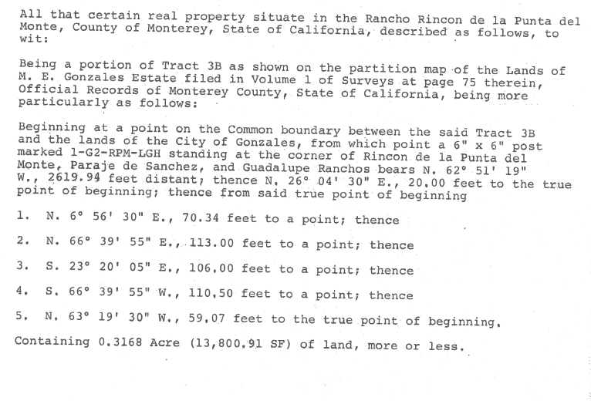

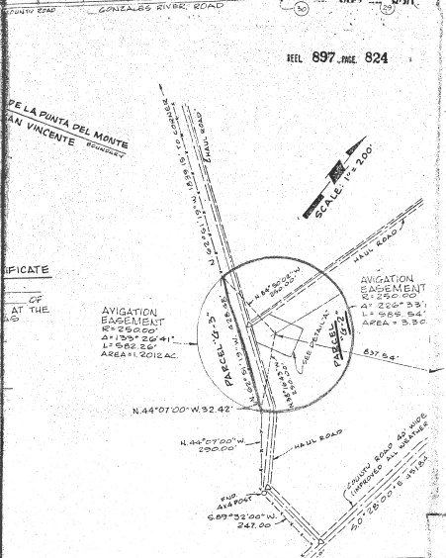
EXHIBIT “B”

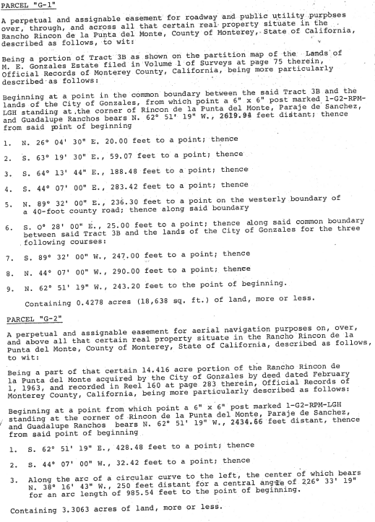

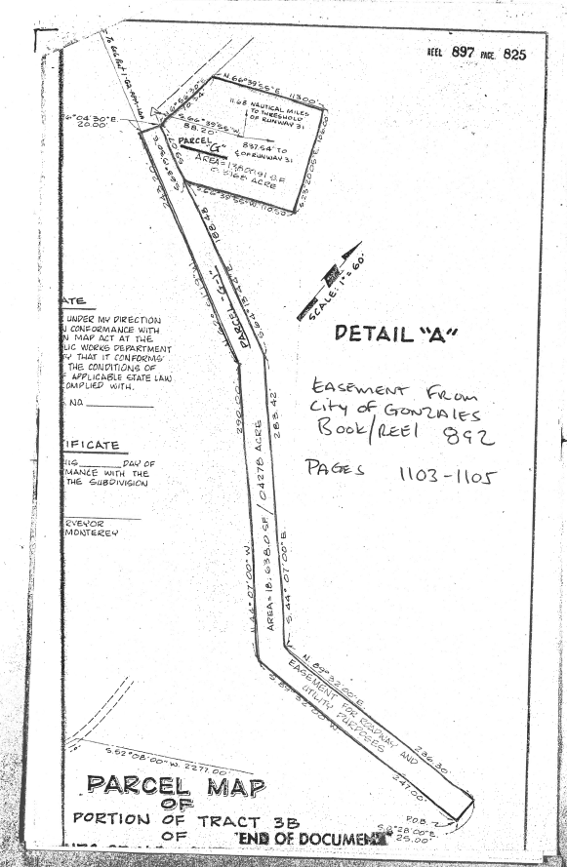
EXHIBIT “C”
RECORDING REQUESTED BY

City of Gonzales
PO Box 647
Gonzales, CA 93926
147 Fourth Street
Attention: Rene Mendez, City Manager

WHEN RECORDED MAIL TO
AND MAIL TAX STATEMENTS TO:

City of Gonzales
PO Box 647
Gonzales, CA 93926
147 Fourth Street
Attention: Rene Mendez, City Manager

(ABOVE SPACE FOR RECORDER’S USE ONLY)
No Recording Fee pursuant to Government Code Section 27383
GRANT DEED
For valuable consideration, CITY OF SALINAS, a California municipal corporation and charter city (“Grantor”), does hereby GRANT to CITY OF GONZALES all of the right, title and interest of Grantor in and to that certain real property situated in the City of Gonzales, County of Monterey, State of California, more particularly described on Attachment No. 1 attached hereto and incorporated herein by this reference.
Dated this ____ day of _______, 2022.
CITY:
CITY OF SALINAS, a California municipal corporation and charter city
By: _________________________________
Steven S. Carrigan, City Manager
ATTEST:

Patricia M. Barajas, City Clerk

ATTACHMENT NO. 1 TO GRANT DEED

EXHIBIT “D-1”
RECORDING REQUESTED BY AND WHEN RECORDED RETURN TO:

City of Salinas
200 Lincoln Avenue
Salinas, CA 93901
Attention: Andrew Myrick

(ABOVE SPACE FOR RECORDER’S USE ONLY)
No Recording Fee pursuant to Government Code Section 27383
QUITCLAIM DEED
For valuable consideration, CITY OF SALINAS, a California municipal corporation and charter city (“Grantor”), does hereby REMISE, RELEASE, AND FOREVER QUITCLAIM to CITY OF GONZALES all of the right, title and interest of Grantor in and to that certain real property situated in the City of Gonzales, County of Monterey, State of California, also known as Parcel “G-1” and more particularly described on Attachment No. 1 attached hereto and incorporated herein by this reference.
Dated this ___ day of _____________, 2022.
CITY:
CITY OF SALINAS, a California municipal corporation and charter city
By: _________________________________
Steven S. Carrigan, City Manager
ATTEST:

Patricia M. Barajas, City Clerk

ATTACHMENT NO. 1 TO QUITCLAIM DEED
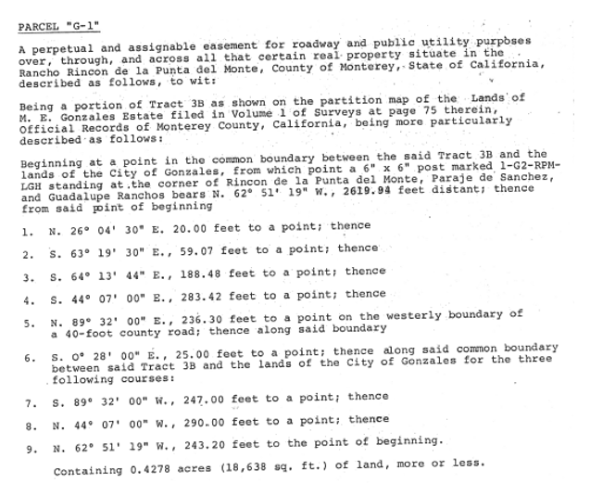

EXHIBIT “D-2”
RECORDING REQUESTED BY AND WHEN RECORDED RETURN TO:

City of Salinas
200 Lincoln Avenue
Salinas, CA 93901
Attention: Andrew Myrick

(ABOVE SPACE FOR RECORDER’S USE ONLY)
No Recording Fee pursuant to Government Code Section 27383
QUITCLAIM DEED
For valuable consideration, CITY OF SALINAS, a California municipal corporation and charter city (“Grantor”), does hereby REMISE, RELEASE, AND FOREVER QUITCLAIM to CITY OF GONZALES all of the right, title and interest of Grantor in and to that certain real property situated in the City of Gonzales, County of Monterey, State of California, more particularly described on Attachment No. 1 attached hereto and incorporated herein by this reference.
Dated this ___ day of _____________, 2022.
CITY:
CITY OF SALINAS, a California municipal corporation and charter city
By: _________________________________
Steven S. Carrigan, City Manager
ATTEST:

Patricia M. Barajas, City Clerk

ATTACHMENT NO. 1 TO QUITCLAIM DEED
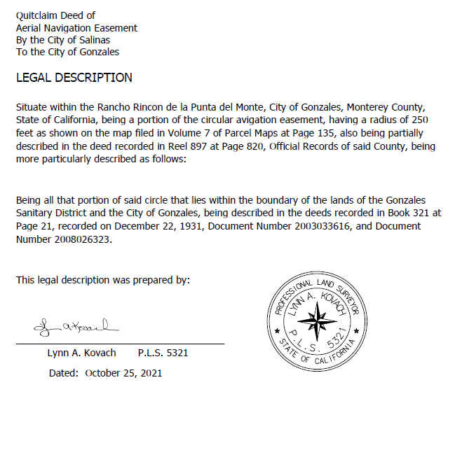

EXHIBIT “D-3”
RECORDING REQUESTED BY AND WHEN RECORDED RETURN TO:

City of Salinas
200 Lincoln Avenue
Salinas, CA 93901
Attention: Andrew Myrick

(ABOVE SPACE FOR RECORDER’S USE ONLY)
No Recording Fee pursuant to Government Code Section 27383
QUITCLAIM DEED
For valuable consideration, CITY OF SALINAS, a California municipal corporation and charter city (“Grantor”), does hereby REMISE, RELEASE, AND FOREVER QUITCLAIM to D’ARRIGO BROS CO all of the right, title and interest of Grantor in and to that certain real property situated in the County of Monterey, State of California, more particularly described on Attachment No. 1 attached hereto and incorporated herein by this reference.
Dated this ___ day of _____________, 2022.
CITY:
CITY OF SALINAS, a California municipal corporation and charter city
By: _________________________________
Steven S. Carrigan, City Manager
ATTEST:

Patricia M. Barajas, City Clerk

ATTACHMENT NO. 1 TO QUITCLAIM DEED
