

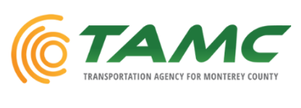
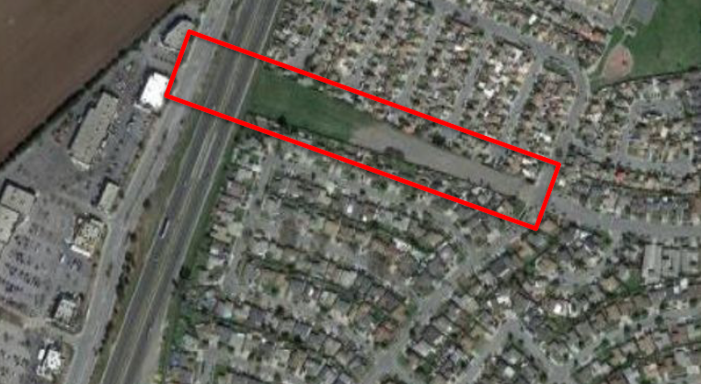
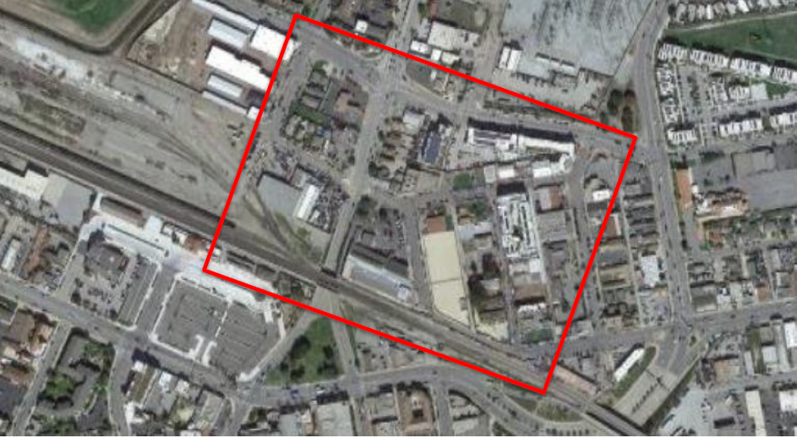
Application Deadline:
October 13, 2022.
** The deadline for applications is 11:59 PM EDT on Thursday, October 13, 2022. All applications must be submitted through grants.gov.
Expected Results
- Conceptual design alternatives.
- Thorough public engagement addressing bicycle and pedestrian crossing needs.
- Economic benefits of addressing the barrier.
- Greater understanding of existing behavior of bicyclists and pedestrians in/around the transportation barriers

Contact:
Sheridan Nansen
Caltrans District 5
sheridan.nansen@dot.ca.gov

Funding summary
Funding Available:
- Planning: $50 mil/yr
- Capital Construction: $148+ mil/yr
Funding Requested:
- $398,400 from USDOT
Total Cost of Project:
- $498,000
Study Purpose
Caltrans, City of Salinas, and Transportation Agency for Monterey County would like to conduct a feasibility study to examine different alternatives for crossing over three (3) major barriers that divide the community:
- US 101 at Alvin Drive
- State Route (SR) 183
- Union Pacific Railroad (UPRR) at SR 183
These barriers divide low-income housing from employment, retail destinations, medical providers, rail and bus transit facilities, and other opportunities. Currently, there are no bicycle or pedestrian facilities that allow the community to cross the barriers comfortably and conveniently.
Study Outcomes
The study will examine:
• Bike and pedestrian mobility
• Accessibility
• Connectivity
• Active Transportation
• Healthier communities
• Goods movement
• Economic development
• Land use efficiency
• Air quality and emissions reduction

Reconnecting Salinas:
Feasibility Study of Key Bicycle and Pedestrian Access Barriers
US 101
ALVIN DR
SR 183
UPRR
SALINAS CHINA TOWN
What is RCP?
It is the first-ever Federal program dedicated to reconnecting communities that were previously cut off from economic opportunities by transportation infrastructure. Funding supports planning grants and capital construction grants, as well as technical assistance, to restore community connectivity through the removal, retrofit, mitigation, or replacement of eligible transportation infrastructure facilities.

