Funding Agreement
CEQA and Planning Services
for Ferrasci Business Center Specific Plan

This Funding Agreement is entered into by and between the City of Salinas, a California charter city and municipal corporation, hereinafter referred to as "the City," and Christopher Steinbruner an individual, and Michael Mueller, an individual, hereinafter referred to as "the Developer" each of which may be individually referred to herein as a "Party" and which may collectively be referred to herein as "the Parties."

RECITALS

WHEREAS, in its Economic Development Element (the “EDE”), the City identified a Future Growth Area outside the City’s current northern boundary for economic development known as Economic Opportunity Area K (EOA K). The lands which comprise EOA K, the “North Entrance” as it is referred to in the EDE, are currently within the County’s jurisdiction and are designated as public/quasi-public, open space, farmlands, permanent grazing, and commercial in the County’s General Plan. EOA K, shown and marked on Figure 1, is comprised of a Target Area, where near to mid-term development is projected by the City, and an Economic Development Reserve Area, also identified on Figure 1, which is to accommodate the City’s longer-term economic development needs; and
WHEREAS, with the adoption of the EDE, the General Plan Land Use and Circulation Map was amended to reflect Business Park and Commercial Retail uses in Target Area K and projected development capacity impacts were evaluated in the EDE Program EIR; and
WHEREAS, the Developer is owner of property within Target Area K located at 180 Harrison Road, Salinas, California (Assessor Parcel Numbers 113-151-002-000, 113-151-011-000 and a portion of 113-161-018-000, the “Property”) and identified on Figure 2; and
WHEREAS, the Developer has submitted applications for the Ferrasci Business Center Specific Plan (Specific Plan) and associated Sphere of Influence Amendment, Annexation (reorganzation), General Plan Amendment and Prezoning of the Property (the “Project”). The Project is expected to include potential future development of approximately 123 acres of currently undeveloped Farmland 40 zoned land consistent with the City’s EDE policies and identified land uses; and
WHEREAS, the City and the Developer agree that a review and study of the environmental impacts associated with development of the Project is necessary and is required under California Environmental Quality Act (CEQA) prior to City’s approval of Project entitlements and Developer's commencement of construction of any part of the Project; and
WHEREAS, the City has entered into an Agreement for Professional Services to complete the review and the study of the environmental impacts associated with development of the Project, tiering off of the EDE Final Program EIR, and to provide support for and prepare environmental documentation for other land use entitlements associated with the Project. Consistent with the Agreement, EMC Planning Group as prepared a scope of work which is attached hereto as Exhibit A; and

WHEREAS, the Developer has agreed to be responsible for all costs and expenses associated with the Consultants' authorized work and city staff time to administer the Consultant Agreement and work on the Project as set forth in Exhibit A; and

WHEREAS, given the City’s limited planning staff resources, the Developer has agreed to be responsible for all authorized staffing and project management and administrative costs and expenses actually incurred with the processing of Project entitlements.

NOW, THEREFORE, in mutual consideration of the covenants, terms, and conditions contained herein, the Parties agree as follows:

TERMS

- Purpose. The purpose of this Agreement is to define the City and the Developer's obligations with regard to the Consultants' completion of a review and study of the environmental impacts and the preparation of environmental documentation for the land use entitlements associated with the Project including General Plan Amendments, Pre-Zoning, Sphere of Influence, Annexation applications, and the Ferrasci Business Center Specific Plan.

- Developer Funding Obligations - Consultants.

  - Developer shall be solely responsible for all costs and expenses actually incurred by EMC Planning Group Inc.’s authorized work on the project and shall reimburse the City for all additional costs and expenses actually incurred by City related to the authorized CEQA analysis rendered by EMC Planning Group Inc. in association with the Project and as further defined in Exhibit A.
  - The total estimated amount of costs and expenses to be incurred by EMC Planning Group Inc. for services and work contemplated in Exhibit A is estimated to be approximately four hundred eighty-six thousand one hundred and twenty-eight dollars and fifty cents ($486,128.50) (the “Consultant Costs”). City and Developer understand and acknowledge the total amount of costs and expenses for project management and CEQA compliance may differ from such estimates due to changes in the scope of work and to circumstances and events now unknown and which may arise during the course of City staff and Consultant’s work. City shall consult with Developer prior to authorizing any change in the scope of work as provided in Exhibit A.

- Developer Funding Obligations – City Staff Costs and Expenses. The Developer shall be solely responsible for all authorized costs and expenses actually incurred by city staff to administer and manage the Consultant’s agreement, application review, and entitlement processing. Staff costs will be calculated based on a fully burdened hourly rate.

- Developer Funding Obligations – Outside Project Management Costs. The Developer shall be solely responsible for all costs and expenses incurred for outside project management costs should the City and the Developer determine that additional outside project management services are required to review and to administer and manage the Consultant’s agreement, review applications, and process Project entitlements in a timely manner. Any such additional outside management services must be authorized by the Developer prior to the initiation thereof.

- Developer Funding Obligations – Administrative Overhead Fee. Developers shall pay the City an administrative fee of fifteen percent (15%) of the total Project Cost including consultant costs and expenses and city staff time for project management and processing of Project entitlements.

- Deposit. Within seven (7) days of the date this Funding Agreement is signed by its authorized representative, the Developer will deposit with the City the sum of Seventy-five thousand dollars ($75,000.00) to be held and applied by the City toward payment of services rendered by EMC Planning Group Inc., City staff, and any authorized outside project management (the “Deposited Funds”).

- Other Application and Development Impact Fees. None of the sums paid by Developers pursuant Sections 2 to 6 shall operate as a credit toward Developer’s obligation to pay any City development impact fee, application fee, processing fee, or other fee established by the City Council other than the City’s standard application fee for the preparation and processing of an environmental impact report or other environmental documentation.

- Specific Plan Application and Processing Fees. Developer paid City Forty-nine thousand, six hundred fifty-four dollars and two cents ($49,654.02) in planning application fees when General Plan Amendment, Pre-Zoning, Sphere of Influence, Annexation, and Specific Plan applications were submitted to the City for review. City staff planning, project management and administrative costs and expenses will be charged against Application and Processing fees until exhausted prior to using Deposit (Section 6).

- Billing. The City shall invoice Developer on a monthly basis. A copy of invoices reflecting expenses billed to the City by EMC Planning Group Inc., for city staff time, and any authorized outside project management cost shall be provided as verification of the amount billed. The City shall pay Consultant cost and outside project management costs and expenses out of the Deposited Funds paid to the City under Section 6.

- Balance of Account. When, at any time, the balance of deposited funds held by the City is less than seventy-five thousand dollars ($75,000), the Developer shall, within seven (7) days after receipt of written notice from the City, make an additional deposit of an amount determined by the City to be sufficient to cover additional anticipated costs and expenses. The City shall keep a full and detailed accounting of all disbursements from the funds so deposited, which accounting shall be made available to the Developer upon request. The Developer understands and agrees that the City will not authorize the EMC Planning Group Inc. or city staff to perform additional services or to continue work on the Project until the Developer has deposited with the City sums sufficient to cover all additional estimated costs and expenses determined by the City to be necessary to fund continued work. Upon completion of Project entitlements, the City shall return to Developer all deposited sums remaining after payment of all costs and expenses within sixty (60) days.

- In the event the Developer fails to pay additional sums necessary to cover additional reimbursable costs and expenses, the City shall have no obligation to continue processing any applications, permits or other approvals requested by the Developer or required for the Project and further the Developer acknowledges that EMC Planning Group Inc. shall have no obligation to continue their work on the Project. Any costs or expenses incurred by the City, or EMC Planning Group Inc. related to the Project shall be considered a debt of the Developer recoverable by the City.

- Indemnification and Hold Harmless. The Developer agrees to and shall at its own cost and expense defend, indemnify, and hold the City and all of its boards, commissions, officers and employees harmless from any and all claims, actions or proceedings to attack, set aside, challenge, void or annul the City’s approval of the environmental review completed by EMC Planning Group Inc.’s on the Project or any other approvals associated with the Project. The City agrees to and shall promptly notify the Developer of any such claim, action or proceeding. Nothing contained in this section shall prohibit the City from participating in the defense of any claim, action or proceeding if the City bears its own attorney fees and costs and the City defends the action in good faith.

The Developer shall reimburse the City for all costs and expenses including, but not limited to, reasonable attorney fees, in addition to any court costs, incurred by City in enforcing the provisions of this section.

- Notices. Written notices shall be sent by first class mail, postage prepaid, to the Parties as follows:

If to City:

Community Development Director
City of Salinas
65 W. Alisal Street, 2nd Floor
Salinas, California 93901

With a Copy to:

City Attorney
City of Salinas
200 Lincoln Avenue
Salinas, California 93901

If to Developer:

Christopher Steinbruner
928 E. Blanco Road, Suite 200
Salinas, CA 93901

Michael Mueller
P.O. Box 7656
Spreckles, CA 93962

With a Copy to:

Horan Lloyd, APC
Attn: Michael Harrington
26385 Carmel Rancho Blvd
Suite 200
Carmel, CA 93923

- Exhibits Incorporated. All exhibits referred to in this Funding Agreement and attached to it, whether at the time of execution or later, are hereby incorporated in it by this reference. In the event there is a conflict bet ween any of the terms of this Funding Agreement and any of the terms of any exhibit to this Funding Agreement, the terms of the Funding Agreement shall control the respective duties and liabilities of the Parties hereto.

- Integration and Agreement. This Funding Agreement represents the entire understanding of City and Developer as to those matters contained herein. No prior oral or written understanding shall be of any force or effect with respect to those matters contained herein. This Funding Agreement may not be modified or altered except by amendment in writing signed by both parties.

- Jurisdiction. This Funding Agreement shall be administered and interpreted under the laws of the State of California. Jurisdiction of any disputes arising from or under this Funding Agreement shall be in the State of California, in the County of Monterey or in the appropriate federal court with jurisdiction over the matter.

- Severability. If any pa rt of this Agreement is found to be in conflict with applicable laws, such part shall be inoperative, null and void insofar as it is in conflict with said laws, but the remainder of the Funding Agreement shall continue to be in full force and effect.

- Attorney Fees. In case suit shall be brought to interpret or to enforce this Funding Agreement, or because of the breach of any other covenant or provision herein contained, the prevailing party in such action shall be entitled to recover their reasonable attorney fees in addition to such costs as may be allowed by the Court. The City's attorney fees, if awarded, shall be calculated a t the market rate.

- Successors and Assigns. This Funding Agreement and all of the provisions herein shall be binding upon and shall inure to the benefit of the heirs, legal representatives, successors, and assigns of the respective Par ties hereto.

IN WITNESS WHEREOF, the undersigned, as authorized representatives of the City of Salinas and of the Developer have executed this Funding Agreement.

CITY OF SALINAS

_____________________________________ ______________________________
Megan Hunter Date
Community Development Department Director

APPROVED AS TO FORM:

_____________________________________ ______________________________
Christopher A. Callihan, City Attorney Date

DEVELOPER

_____________________________________ ______________________________
Christopher Steinbruner Date

_____________________________________ ______________________________
Michael Mueller Date

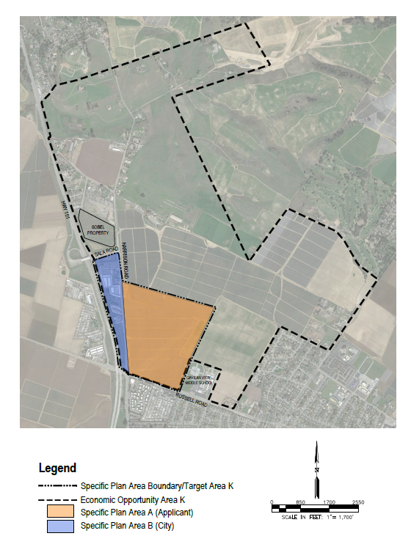
Figure 1

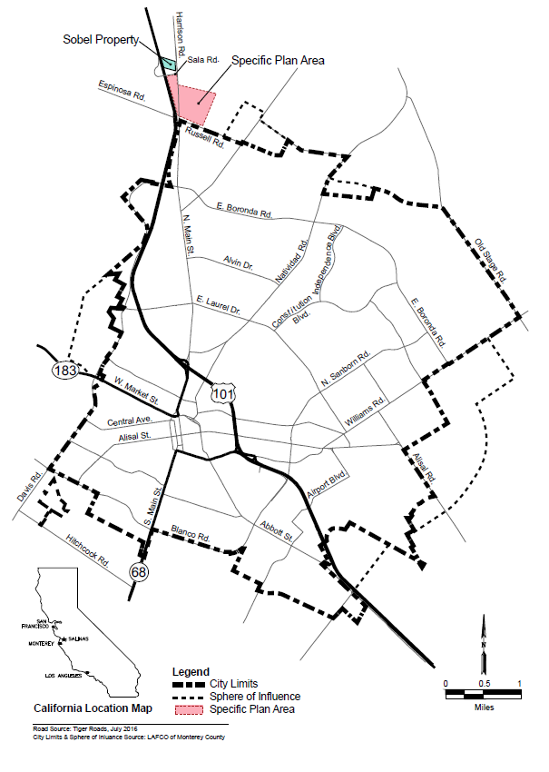
Figure 2

