AGREEMENT FOR SERVICES BETWEEN

THE CITY OF SALINAS AND YOSSO GROUP INC.

Northgate Neighborhood Park Playground Replacement

THIS AGREEMENT is executed this 24th day of September, 2024, (“Agreement” or “Contract”) between the City of Salinas, a California Charter city and municipal corporation (hereinafter “City”) and Yosso Group Inc., a California corporation (hereinafter “Contractor”).

IT IS HEREBY MUTUALLY AGREED AS FOLLOWS:

- Scope. Contractor hereby agrees to provide to the City, as the scope of services under this Agreement, the following services: Labor and material for Northgate Neighborhood Park. Scope of work is further discussed in Attachment B.

- Timeliness. Contractor shall perform all tasks in a timely fashion, as set forth more specifically in Section 3 below. Failure to so perform is hereby deemed a material breach of this Agreement, and City may terminate this Agreement with no further liability hereunder, or the city may agree in writing with Contractor to an extension of time.

- Term. The work under this Agreement shall commence September 24, 2024 and shall be completed by June 30,2025, unless City grants a written extension of time as set forth in Section 2 above.

- Payment. City agrees to pay and Contractor agrees to accept as full and fair consideration for the performance of this Agreement, in an amount not to exceed nine hundred seventy-four thousand ninety and fifty-four hundredths ($974,090.54), as more fully described in title of Contractors fee schedule, Attachment B. Contractor has no right of reimbursement for expenses under this Agreement. Compensation shall become due and payable 30 days after City’s approval of Contractor’s submission of monthly written invoices to the City. The payment of any compensation shall be contingent upon performance of the terms and conditions of this Agreement to the satisfaction of the City. If City determines that the work set forth in the written invoice has not been performed in accordance with the terms of this Agreement, City shall not be responsible for payment until such time as the work has been satisfactorily performed.

- Meet & Confer. Contractor agrees to meet and confer with City or its agents or employees with regard to services as set forth herein as may be required by City to insure timely and adequate performance of this Agreement.

- Insurance. Contractor shall procure and maintain for the duration of this Agreement insurance meeting the requirements specified in Attachment A hereto.

- Indemnification. Contractor shall hold harmless, defend at its own expense, and indemnify City and its officers, officials, employees, agents, and volunteers from and against all liability, claims, damages, losses, and/or expenses including reasonable City attorney fees arising from all acts or omissions of Contractor or its officers, agents, or employees arising out of the performance of the work under this Contract, caused in whole or in part by any negligent act or omission of the Contractor, any subcontractor, anyone directly or indirectly employed by any of them, or anyone for whose acts any of them may be liable, except where caused by the tive negligence, sole negligence or willful misconduct of the City.

- Licensing. Contractor warrants that it is properly licensed to perform the work specified under this Agreement, including but not limited to possession of a current City business license.

- Termination. City may terminate this Agreement upon ten days’ written notice. The amount of damages, if any, as a result of such termination may be decided by negotiations between the parties or before a court of competent jurisdiction.

- Agency. In performing the services specified under this Agreement, Contractor is hereby deemed to be an independent contractor and not an agent or employee of City.

- Non-Assignability. The rights and obligations of Contractor hereunder are not assignable and cannot be delegated without written consent of City.

- Entire Agreement. This Agreement constitutes the entire Agreement between the parties hereto and supersedes any and all prior agreements, whether oral or written, relating to the subject matter thereof. Any modification of the Agreement will be effective only if it is in writing signed by both parties hereto.

- Validity. If any provision in this Agreement is held by a court of competent jurisdiction to be invalid, void or unenforceable, the remaining provisions will continue in full force without being impaired or invalidated in any way.

- Counterparts. This Agreement may be executed in multiple originals, each of which is deemed to be an original, and may be signed in counterparts.

- Laws. Contractor agrees that in the performance of this Agreement it will comply with all applicable State, Federal and local laws and regulations. This Agreement shall be governed by and construed in accordance with the laws of the State of California, County of Monterey, and City of Salinas.

IN WITNESS WHEREOF, this Agreement is entered into by the parties hereto on the day and year first written above.

CITY OF SALINAS

__________________________________
René Mendez, City Manager

APPROVED AS TO FORM:

_________________________________
Christopher A. Callihan, City Attorney, or
Rhonda Combs, Assistant City Attorney

CONTRACTOR

___________________________________

By (Printed Name):___________________

Its (Title):___________________________

Attachment A

Insurance Requirements

Contractor shall procure and maintain for the duration of the contract, and for three years thereafter, insurance against claims for injuries to persons or damages to property which may arise from or in connection with the performance of the work hereunder by the Contractor, his/her/its officers, agents, representatives, employees, and/or subcontractors.

MINIMUM SCOPE AND LIMIT OF INSURANCE
Coverage shall be at least as broad as:
1. Commercial General Liability (“CGL”): Insurance Services Office (“ISO”) Form CG 00 01 covering CGL on an occurrence basis, including products and completed operations, property damage, bodily injury and personal & advertising injury with limits no less than $2,000,000 per occurrence. If a general aggregate limit applies, either the general aggregate limit shall apply separately to this project/location (ISO Form CG 25 03 or 25 04) or the general aggregate limit shall be twice the required occurrence limit.
2. Automobile Liability: ISO Form CA 0001 covering Code 1 (any auto), with limits no less than $1,000,000 per accident for bodily injury and property damage.
3. Workers’ Compensation: as required by the State of California, with Statutory Limits, and Employers’ Liability insurance with a limit of no less than $1,000,000 per accident for bodily injury or disease.
4. Contractors’ Pollution Legal Liability and/or Asbestos Legal Liability and/or Errors and Omissions (if project involves environmental hazards): with limits no less than $1,000,000 per occurrence or claim, and $2,000,000 policy aggregate, on an annual basis.

If the Contractor maintains broader coverage and/or higher limits than the minimums shown above, the Contractor requires and shall be entitled to the broader coverage and/or higher limits maintained by the Contractor. Any available insurance proceeds in excess of the specified minimum limits of insurance and coverage shall be available to the City.

Self-Insured Retentions
Self-insured retentions must be declared to and approved by the City. At the option of the City, either: the Contractor shall cause the insurer shall to reduce or eliminate such self-insured retentions as respects the City, its officers, officials, employees, and volunteers; or the Contractor shall provide a financial guarantee satisfactory to the City guaranteeing payment of losses and related investigations, claim administration, and defense expenses. The policy language shall provide, or be endorsed to provide, that the self-insured retention may be satisfied by either the named insured or City.

Other Insurance Provisions
The insurance policies are to contain, or be endorsed to contain, the following provisions:
1. The City, its officers, officials, employees, and volunteers are to be covered as additional insureds on the CGL policy with respect to liability arising out of work or operations performed by or on behalf of the Contractor including materials, parts, or equipment furnished in connection with such work or operations and automobiles owned, leased, hired, or borrowed by or on behalf of the Contractor. General liability coverage can be provided in the form of an endorsement to the Contractor’s insurance (at least as broad as ISO Form CG 20 10, CG 11 85 or both CG 20 10, CG 20 26, CG 20 33, or CG 20 38; and CG 20 37 forms if later revisions used).
2. For any claims related to this project, the Contractor’s insurance coverage shall be primary insurance coverage at least as broad as ISO CG 20 01 04 13 as respects the City, its officers, officials, employees, and volunteers. Any insurance or self-insurance maintained by the City, its officers, officials, employees, or volunteers shall be excess of the Contractor’s insurance and shall not contribute with it.
3. Each insurance policy required by this clause shall provide that coverage shall not be canceled, except with notice to the City.
4. A copy of the claims reporting requirements must be submitted by Contractor to the City.
5. If the services involve lead-based paint or asbestos identification/remediation, the Contractor’s Pollution Liability policy shall not contain lead-based paint or asbestos exclusions. If the services involve mold identification/remediation, the Contractor’s Pollution Liability policy shall not contain a mold exclusion, and the definition of Pollution shall include microbial matter, including mold.

Acceptability of Insurers
Insurance is to be placed with insurers authorized to conduct business in the state with a current A.M. Best rating of no less than A: VII, unless otherwise acceptable to the City.

Waiver of Subrogation
Contractor hereby agrees to waive rights of subrogation which any insurer of Contractor may acquire from Contractor by virtue of the payment of any loss. Contractor agrees to obtain any endorsement that may be necessary to affect this waiver of subrogation. The Workers’ Compensation policy shall be endorsed with a waiver of subrogation in favor of the City for all work performed by the Contractor, its employees, agents and subcontractors.

Verification of Coverage
Contractor shall furnish the City with original Certificates of Insurance including an additional insured endorsement and all required amendatory endorsements (or copies of the applicable policy language effecting coverage required by this clause) and a copy of the Declarations and Endorsement Page of the CGL policy listing all policy endorsements to City before work begins. However, failure to obtain the required documents prior to the work beginning shall not waive the Contractor’s obligation to provide them. The City reserves the right to require complete, certified copies of all required insurance policies, including endorsements, required by these specifications, at any time.

Subcontractors
Contractor shall require and verify that all subcontractors maintain insurance meeting all the requirements stated herein, and Contractor shall ensure that City is an additional insured on insurance required from subcontractors. For CGL coverage subcontractors shall provide coverage with a form at least as broad as CG 20 38 04 13.

Maintenance of Insurance
Maintenance of insurance by Contractor as specified shall in no way be interpreted as relieving Contractor of its indemnification obligations or any responsibility whatsoever and the Contractor may carry, at its own expense, such additional insurance as it deems necessary.

Special Risks or Circumstances
City reserves the right to modify these requirements, including limits, based on the nature of the risk, prior experience, insurer, coverage, or other special circumstances.

Attachment B

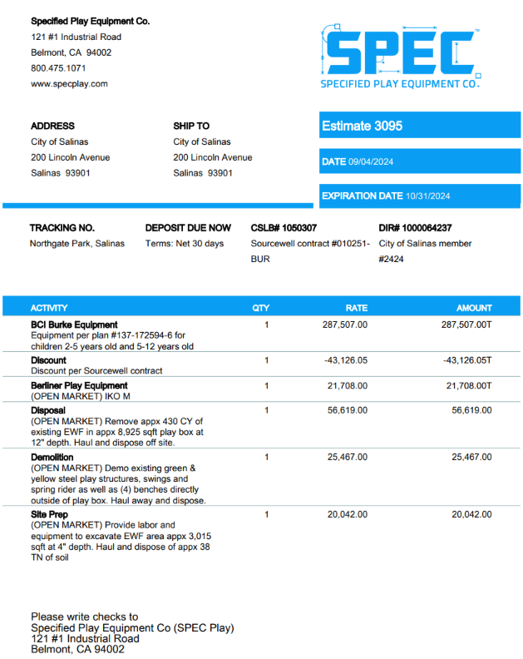
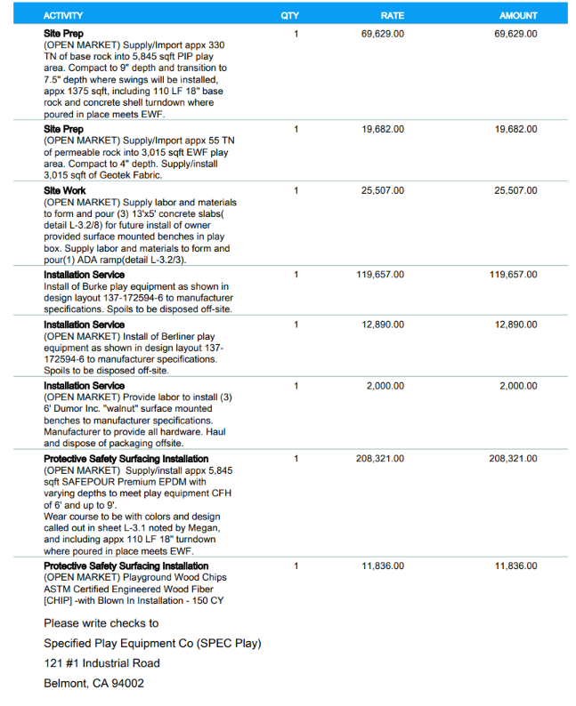
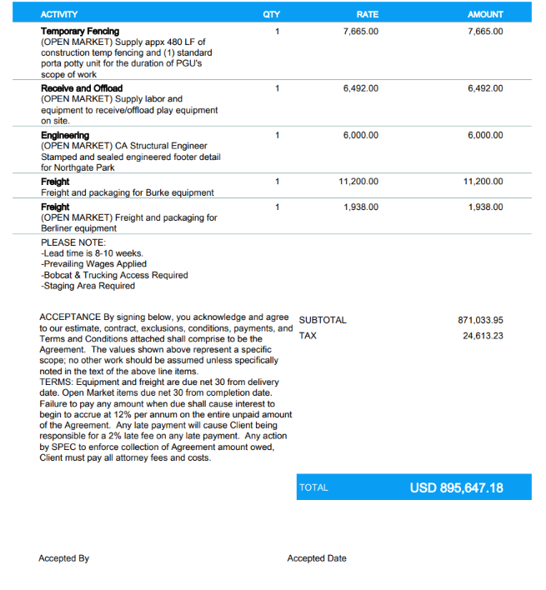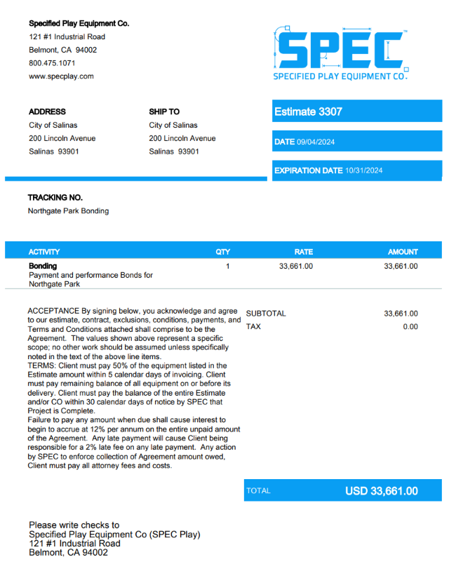

Attachment C
DEPARTMENT OF INDUSTRIAL RELATIONS’ STATE LABOR CODE
Labor Law Requirements
(CCR Title 8, Section 16421)

This public works project is subject to compliance monitoring and enforcement by the California Department of Industrial Relations (“DIR”). All work shall be in accordance with wage scales and applicable determinations made by the Director of the DIR, as provided by Article 2, Chapter 1, Division 2, Part 7 of the Labor Code of the State of California, commencing with §1771.

Penalties for violations may be applied by the DIR pursuant to the Labor Code §1813 and §1815. The Contractor shall indemnify, hold harmless, and defend the City (with counsel reasonably approved by the City) against any claim for damages, compensation, fines, penalties, or other amounts arising out of the failure or alleged failure of any person or entity (including Contractor and its subcontractors) to pay prevailing wages as determined pursuant to Labor Code §1720, and hereby agrees to, §§1771-1774; to employ apprentices pursuant to Labor Code §1777.5 et seq., and/or to comply with the other applicable provisions of Labor Code §1720 et seq., §§1771-1774, §1777.5 et seq., and the implementing regulations of the DIR in connection with the scope of work. This indemnification section shall survive the expiration of the Term.

The Federal and State Labor Law requirements applicable to the Agreement are composed of, but not limited, to the following items:

- Payment of Prevailing Wage Rates: All contractors, including subcontractors, shall pay no less than the prevailing rate of wages (Labor Code §1775), including the rates for holidays and overtime work (Labor Code §§1813 and 1815), to all workers employed in the execution of the contract (Labor Code §1774), pursuant to Labor Code §§1720-1784. The prevailing rates are those issued as wage determinations by the DIR, for each craft, classification and type of work. The current wage rate information can be found at the DIR’s website at: https://www.dir.ca.gov/oprl/DPreWageDetermination.htm.
Copies of the prevailing rate of per diem wages are on file at City’s Public Works Department (principal place of office). Contractor shall post a copy of the determination of the Director of DIR of the prevailing rate of per diem wages at each job site.
- Apprentices: Contractor and subcontractors shall employ registered apprentices on this public works Agreement pursuant to Labor Code §1777.5. All contractors on this project (prime and subcontractors) are required to submit the Division of Apprenticeship Standards’ (“DAS”) Public Works Contract Award Information (DAS 140) form to all applicable apprenticeship committees no later than 10 days before commencing work. Additionally, all contractors are required to request registered apprentices (DAS 142 form).
Penalties for failure to pay prevailing wages (for non-exempt projects) and failure to employ apprentices include forfeitures and debarment under Labor Code §§1775 and 1777.7.
- Certified Payroll Records: All contractors, including subcontractors, must maintain and file certified payroll records (“CPRs”) pursuant to Labor Code §1776. Additionally, all contractors and subcontractors must furnish certified payroll records into the DIR’s Electronic Certified Payroll Reporting (“eCPRs”) database (https://efiling.dir.ca.gov/eCPR/pages/eCPROnlineForm.jsp). Penalties apply to Contractor and any Subcontractors for failure to do so under Labor Code §1777.
- Subcontracting: Contractors are required to list all subcontractors hired to perform work on this public works agreement.
- Proper Licensing/Registration: All contractors and subcontractors are required to be properly licensed, in accordance with the Provisions of Chapter 9 of Division 3 of the Business and Professions Code and subject to the requirements of §4104 of the Public Contract Code. In addition, all contractors including subcontractors must submit proof of current registration to perform public work, pursuant to Labor Code §1771.1. Contractors are required to be properly licensed and to require all subcontractors to be properly licensed. Penalties for employing workers while unlicensed under Labor Code §1021 and under the California Contractors License Law, found at Business and Professions Code §7000 et. seq.
- Job Site Notices: Contractors are required to post all required notices (posters) on the job site in an area accessible to all workers, including subcontractors. Posters must be readable and placed in visible areas allowing workers to access the posters before, during, and after work shifts. Jobsites with multiple locations must include a portable poster board to ensure continued access to the information. Posters placed in foreman, supervisor, or employee vehicles, in an offsite job trailer, or inside a temporary restroom do not meet the posting requirement. Posters may be printed from the DIR’s website at: http://www.dir.ca.gov/wpnodb.html.
- Nondiscrimination in Employment – Equal Employment Opportunity (“EEO”): Employment discrimination is prohibited, pursuant to Labor Code §1777.6, the Government Code, and Title VII of the Civil Rights Act of 1964.
- Kickbacks Prohibited: Contractors and subcontractors are prohibited from recapturing wages illegally by accepting or extracting “kickbacks” from employee wages pursuant to Labor Code §1778.
- Acceptance of Fees Prohibited: Contractors and subcontractors are prohibited from accepting fees for registering any person for public work or for filling work orders on public works contracts, pursuant to Labor Code §§1779 and 1780.
- Unfair Competition Prohibited: Contractors and subcontractors are prohibited from engaging in unfair competition as specified under Business and Professions Code §§17200 - 17208.
- Workers’ Compensation: Contractors and subcontractors must be properly insured for Workers’ Compensation under Labor Code §1861. Contractor hereby represents that Contractor is aware of the provisions of Section 3700 of the Labor Code, which require every employee to be insured against liability for Workers’ Compensation or to undertake self-insurance in accordance with the provisions of that Code, and Contractor will comply with such provisions before commencing the performance of the work of this agreement.
- OSHA: Contractors and subcontractors must abide by the Occupational, Safety, and Health Laws and regulations that apply.

