DATE: SEPTEMBER 24, 2024
DEPARTMENT: LIBRARY & COMMUNITY SERVICES
FROM: KRISTAN LUNDQUIST, DIRECTOR
BY: ANA AMBRIZ, REC-PARK SUPERINTENDENT
TITLE: AGREEMENT WITH YOSSO GROUP INC. FOR THE REPLACEMENT OF THE PLAYGROUND STRUCTURE AT NORTHGATE NEIGHBORHOOD PARK

RECOMMENDED MOTION:

A motion to approve a Resolution authorizing the City Manager to negotiate and execute an agreement with Yosso Group Inc. for the replacement of the playground structure at Northgate Neighborhood Park in an amount not to exceed $974,090.54.

EXECUTIVE SUMMARY:

On March 11, 2021, President Biden signed the American Rescue Plan Act (ARPA), which provided the City of Salinas with $51,567,313 in relief funds. In September 2021, the City Council allocated ARPA funds for a number of government service projects, including $2 million dollars for playground structures, park benches and bar-be-que grills, the majority of which was to be spent in the 93905 and 93906 zip codes which were hit hardest by the COVID-19 pandemic. With the allocation, the Council Resolution called for staff to check in with the Finance Committee on these and the Public Works sidewalk/street repair allocations. In May 2022, staff provided an updated to the Finance Committee on the recommended projects identified for ARPA funding. This report included playground two new playground structures at Williams Ranch and Northgate Neighborhood Parks.

DISCUSSION:

The City of Salinas has 35 playgrounds located in parks/facilities across the City. An assessment of the playgrounds was conducted as part of the Parks, Recreation & Libraries Master Planning effort in 2017. The majority of the playgrounds were found to be in fair and/or good condition. The playground at Williams Ranch Neighborhood Park was found to be in poor condition and in need of replacement.

On December 13, 2022, the City Council authorized the City Manager to enter into a Professional Services Agreement (PSA) between the City of Salinas and BFS Landscape Architects (BFS) for program and construction management of multiple projects to include the development of universal playgrounds concepts for Northgate and Williams Ranch Neighborhood Parks.

BFS requested concepts from playground manufacturers and presented them to staff. After review, the 3 concept alternatives were presented to community in the Northgate Park neighborhood. Engagement consisted of an online survey and pop-up activities for each of the sites at the end of 2023. The goal was to get community’s preference on the presented concept and site amenities. Pop-up activities for Northgate occurred at the park itself, Henry F. Kamman Elementary School and Harden Middle School. The in-person event at Henry F. Kamman Elementary recorded 140 unique votes on the playground design alternatives, the Harden Middle School received 99 unique votes, and the online survey recorded 51 responses. The preferred concept was submitted by Yosso Group Inc. and is illustrated below.

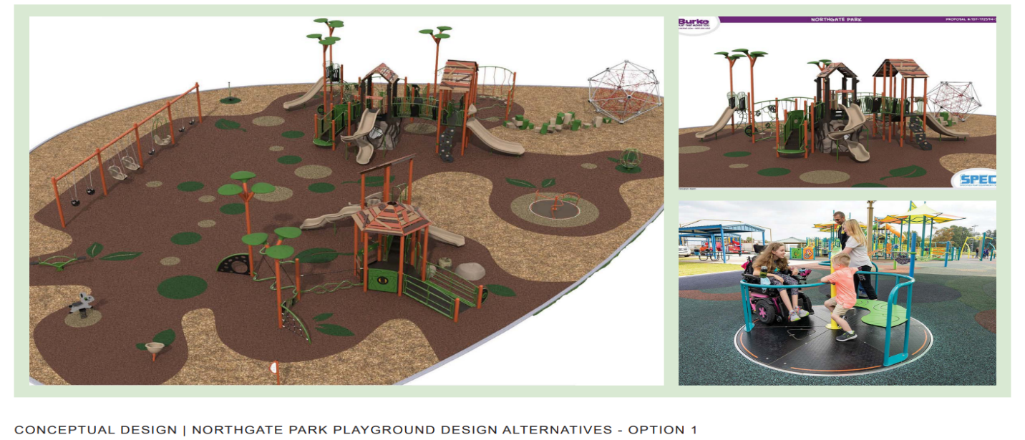
Sourcewell (formerly National Joint Powers Alliance) has a contract with Yosso Group Inc. and can provide and install the playground equipment at Northgate Park for $929,308.18. In addition, staff would like to request a 5% contingency for any unforeseen issues that may arise. Sourcewell is a cooperative purchasing organization, and the City Council can approve this purchase under, cooperative purchase with other government agencies and Section 12-25.

The City Council may authorize the direct purchase through this vendor pursuant to Salinas Municipal Code sections 12-27 and 12-28.080. The replacement of this playground plus the 5% contingency would total $974,090.54.

CEQA CONSIDERATION:

The City of Salinas has determined that the replacement of the existing structure is substantially the same size, purpose, and capacity, qualify as a Class 2 Categorical Exemption (Section 15302 Replacement or Reconstruction) under the California Environmental Quality Act (CEQA).

CALIFORNIA GOVERNMENT CODE §84308 APPLIES:

Yes

STRATEGIC PLAN INITIATIVE:

The playground repairs are consistent with the City Council Goals of:
- Youth and Seniors
- Infrastructure and Environmental Sustainability
- Public Safety

DEPARTMENTAL COORDINATION:

Library & Community Services, Community Development and Public Works collaborated on developing scope and selecting BFS to provide project and construction management services for this project. Collaboration between the three departments will continue through the building permit process and construction.

FISCAL AND SUSTAINABILITY IMPACT:

Fund | Appropriation | Appropriation  Name | Total Appropriation | Amount for recommendation | FY 24-25 Operating Budget Page | Last Budget Action (Date, Resolution)
3911 | 55.8171-66.4000 | Capital Outlays Improvements | $1,764,367.20 | $470,000 | n/a | 11/16/2021, 22250
5800 | 55.9060-66.4000 | Capital Outlays Improvements | $652,854 | $504,090.54 | n/a | 12/13/2022, 22550

ATTACHMENTS:
Resolution
Agreement with Yosso Group Inc.

